


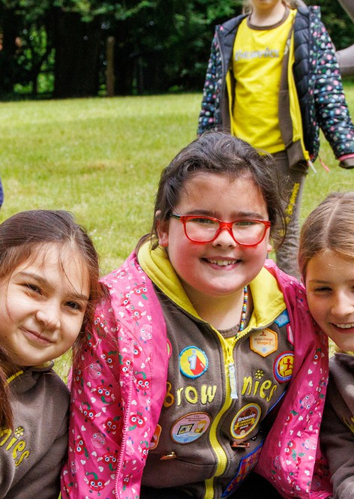



Girls have nonstop fun, learning and adventure
for ages 7 to 10
'I like doing things outside... we get to learn about our environment and how to care for it'
Add email address here
Contact us:
County/unit here
Add Facebook here
Add phone number here
Add website here
Jessica

