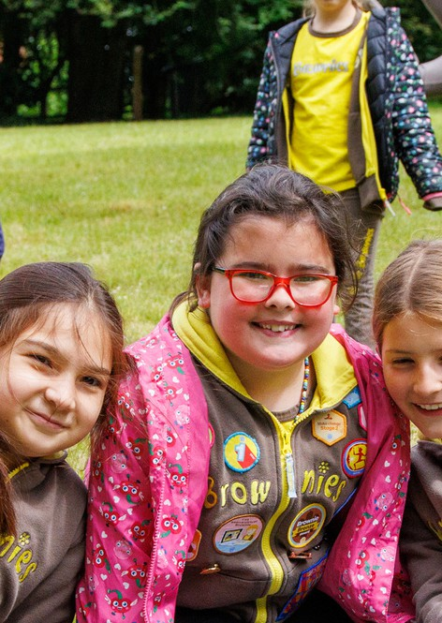

Girls have nonstop fun, learning and adventure

for ages 7 to 10

'I like doing things outside... we get to learn about our environment and how to care for it'

*Add email address here*

**Contact us:**

*County/unit here*

*Add Facebook here*

*Add phone number here*

*Add website here*

**Jessica**