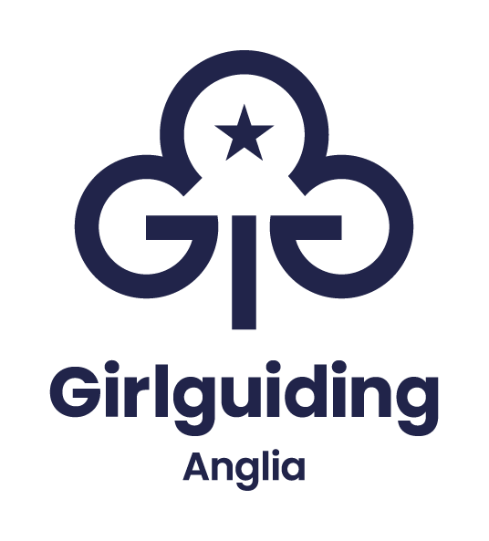

Information and application pack

Caterer

Permanent
Full time 35 hours per week
£22,222 per annum

Based near Coltishall, Norwich
Hybrid working available, minimum 60% office based.

Closing date: Thursday 12 October 2023

Overview

Girlguiding Anglia is looking for a Caterer to join their team at the Hautbois activity centre.
Based in the stunning Norfolk countryside, you will be supporting the catering manager and management team to produce a high-quality catering service; plan, assist in supervising and develop the catering service at Hautbois to meet customer expectations, food hygiene standards and financial targets.
You will be responsible for the following of policies and procedures, ensuring that all legal and regulatory requirements are met and assisting with their develop as regulations change.
There will be evening and weekend working to support business needs.
We offer our team members free car parking, office drinks, increasing holiday allowance based on years’ service and modern IT and working facilities.
If you have any questions regarding this role and person specification or would like to discuss the opportunity further, please contact Rowena Howard.

For more information contact
Rowena Howard
rowena.howard@hautbois.org.uk

01603 737357 ext 205

Job Description

Post: Caterer

Responsible to: Hautbois committee

Line management: Catering manager

Purpose
The role of the caterer is to support and assist the catering manager and management team to produce a high-quality catering service; plan, assist in supervising and develop the catering service at Hautbois to meet customer expectations, food hygiene standards and financial targets.
The caterer is responsible for the following of policies and procedures, ensuring that all legal and regulatory requirements are met and assisting with their develop as regulations change.

Main duties for the post:
The duties are likely to vary so an ability to work flexibly will be essential.
Catering Provision
• To prepare, cook and serve meals to guests.
• To assist and support the catering manager in all aspects of the catering provision including to organise, and motivate the catering team, training seasonal staff as required.
• To regularly monitor the quality of the catering provision, food hygiene and to ensure the highest standards are maintained.
• To assist and support the catering manager to manage the catering facilities and resources, e.g. checking event bookings and allocation of resources and staff.
• To keep abreast of trends and developments in catering such as menus, trends in consumer tastes and statutory and regulatory issues.
• To plan menus in consultation with group leaders or event coordinators, considering seasonal variations, the provision of a healthy balanced diet and any special dietary needs as required.
• To prepare the dining areas for weekday and weekend events.
• To assist the catering manager to plan promotions, special events and contribute to business development.
Health & Safety
• To ensure all health and safety regulations are strictly observed, including cleaning schedules, documentation and wearing of appropriate clothing.
• To ensure all necessary Health & Safety requirements are met with regard to food hygiene, COSHH, Manual Handling and other regulatory requirements.
• To ensure all catering equipment is maintained in accordance with regulations and best practice.
Other Areas
• To interact with customers appropriately as a customer facing member of the team.
• To answer the telephone and door to suppliers and guests and deal with them in a friendly, helpful, and polite manner.
• To assist the housekeeping team and maintenance team as and when reasonably required. All staff may be asked to complete tasks outside of their usual job role as required to suit business needs.
All Anglia region office staff will be expected to:
- Build and maintain good working relationships with all colleagues and volunteers across Girlguiding
- Take reasonable care for the health and safety of self and others. Co-operate fully with the management of the company regarding Health and Safety legislation allowing that duty or requirement to be carried out or complied with
- Keep confidential all matters relating to Girlguiding Anglia in accordance with current legislation, including storage and release of digital information and data
- Ensure Girlguiding Anglia promotes a positive, professional image at all times
- Be an active team member, taking on additional responsibilities where appropriate to support others and promote excellent customer service
- Be able to evidence Girlguiding’s values at all times, which underpin Girlguiding’s mission of ‘being our best’

Additional information

This role will require working weekends and weekday evenings.

Line Manager | Catering manager
Working Hours | 35 hours per week. Rotas are flexible to cover evenings and weekends as required. May include occasional split shifts during peak periods. Rotas will be issued in advance but could be subject to change with sufficient notice.
Location | Hautbois Activity Centre, 5 Gt Hautbois Road, Coltishall, Norfolk, NR12 7JN
Contract type | Permanent
Salary | Grade A, £22,222.00

This is an outline job description designed to give an overview of the responsibilities of the role. We expect the job holder will work flexibly, responding to organisational needs and changes as they occur. You will also contribute to the wider corporate and organisational needs of Girlguiding Anglia.

Person Specification

Factor | Essential | Desirable | Method of assessment
Education and qualifications | - NVQ level2 in Catering or a minimum of 2 years’ experience in a catering environment, preferably residential.  - CIEH Food Hygiene – Level 2 minimum |  | Checking original certification
Experience: | - An excellent understanding of Health & Safety and food hygiene Regulations applying to kitchens  - Proven ability to work positively and constructively with staff and volunteers at all levels  - Ability to use the computer software as shown and required.  - Proven ability of multi-tasking to meet deadlines  - Proven experience of working within a small catering team | - Experience of catering for children and those with special dietary requirements. | Via application form and verified by references.  Through appropriate questions and answers at interview.
Ability to | - Proven ability to work on own initiative  - Ability to organise own time/workload and achieve deadlines  - Ability to assist the Housekeeping Co- ordinator with the administrative and regulatory needs of a kitchen environment, including stock control, ordering and time management. |  | Via application form and verified by references.  Through appropriate questions and answers at interview.
Knowledge of | - Food Hygiene  - Allergens  - COSHH | - Interest in nutrition | Via application form and verified by references.  Through appropriate questions and answers at interview.
Committed to | - Joint working to achieve the overall aims of Girlguiding Anglia  - Supervision and appraisal  - Participation in team meetings and reflective discussions.  - Promoting Girlguiding Anglia and our services at all times |  | Via application form and verified by references.  Through appropriate questions and answers at interview.
Additional requirements | - Weekend and evening working as required | - Ability to drive and have access to a car | Checking original certification.  Via application form and interview.

Explanation
When completing the enclosed application form, please be aware that the person specification will be used in determining the shortlist for interview.
Only information provided by you on the application form can be used when making this decision.

Application form
Role applied for: Caterer

Personal Details
First name(s)
Surname (family name)
Home address (including postcode)
Contact details
Phone
Email

Declaration by applicant
I confirm that the information in this application form is correct. I understand that any false information or deliberate omissions which may impact upon or affect my ability to perform this role will disqualify me from employment or may render me liable for dismissal.

I agree that the information I have supplied can be stored digitally or held manually following UK General Data Protection Regulations.

I consent to Girlguiding Anglia (and their professional advisers) using and keeping information I have provided on this application form or elsewhere as part of the recruitment process and/or personal information supplied by third parties such as referees, relating to my application or future employment. The privacy notice can be viewed on Girlguiding Anglia’s website.

I understand that the information provided will be used to decide my suitability for employment and if successful the information will be used to form my personnel record and will be retained for the duration of my employment. If I am not successful, I understand that Girlguiding Anglia will retain my information for up to 6 months after which time it will be destroyed.

By submitting my application, I consent to all of the above.

Employment History
Starting with your present or most recent job, please give a summary of all employment, including any freelance and relevant unpaid/voluntary work. Please continue on another sheet if needed.

Present employment
Name and address of employer:

Dates of employment:

Job title:

Brief details of your responsibilities

Notice required in current position:
Employment history
Name and address of employer:

Dates of employment:

Job title:

Brief details of your responsibilities:

Name and address of employer:

Dates of employment:

Job title:

Brief details of your responsibilities:

Name and address of employer:

Dates of employment:

Job title:

Brief details of your responsibilities:

Qualifications and training
Starting with the most recent, please give details of your education, qualifications and training relevant to this application.

Qualifications

Dates | Name of educational institution or training provider | Qualifications obtained including grades, and/or training relevant to the application

Training

Dates | Name of educational institution or training provider | Qualifications obtained including grades, and/or training relevant to the application

Please note, should you be offered employment we may ask you to provide evidence of relevant qualifications.

Skills, abilities, and experience
Using the job description and person specification please outline the skills, experience, and knowledge you have to deliver this role.

Final statement
Why would you like us to consider you for this role?

References
Please give the full details of two referees, including your present employer where applicable. Personal or academic referees should be given only when there is no previous employer to which reference can be made.

Reference 1
Name
Position
Telephone
Email
Relationship to you
Can references be taken up before the interview?

Reference 2
Name
Position
Telephone
Email
Relationship to you
Can references be taken up before the interview?

Other
Please tell us where you saw the role advertised
Referred by a member of staff
UK Work Restrictions
Are there any restrictions on you taking up employment in the UK?
Do you need a work permit to take up employment in the UK?

Return your application by:
Email to: hr@girlguiding-anglia.org.uk
Or by post, marked private and confidential to:
Vacancies at Girlguiding Anglia. 7 Great Hautbois Road, Coltishall, Norwich. NR12 7JN

Closing date for applications: Monday 1st December 2025 at 17.00pm.
Interviews: week commencing Monday 8th December 2025.
Should you not receive an acknowledgement within 24 working hours of sending your application please contact us at 01603 737 357 (option 1)

Equality and Diversity Monitoring
Girlguiding Anglia wants to meet the aims and commitments set out in its equality policy. This includes not discriminating under the Equality Act 2010.

We want everyone to feel comfortable and supported when applying to join Girlguiding Anglia. If you have a disability or think you might need any adjustments during the recruitment process, just get in touch with our HR officer at HR@girlguiding-anglia.org.uk
We are happy to discuss how we can best support you.

