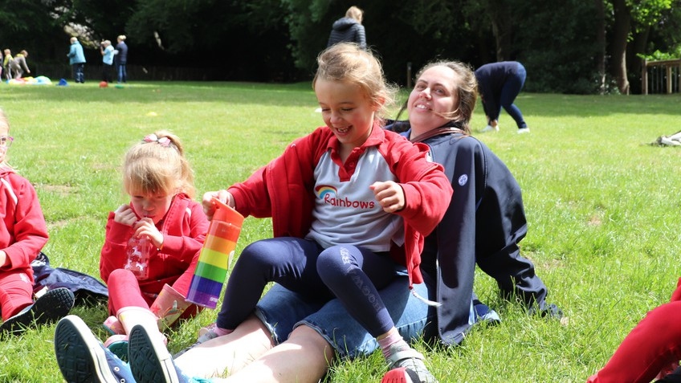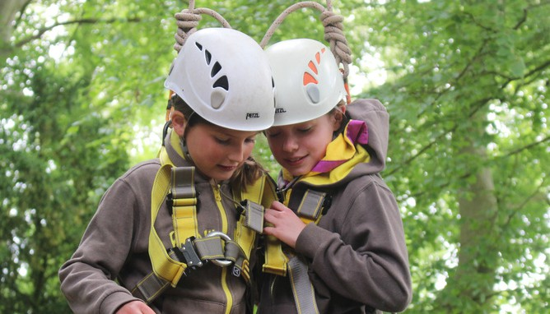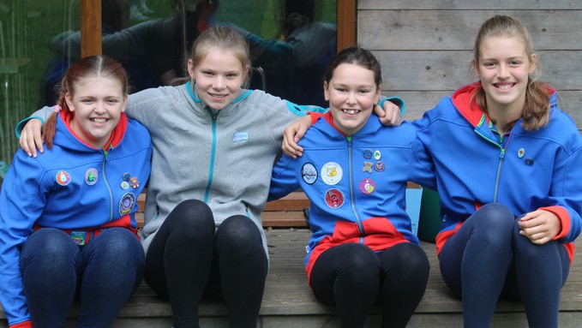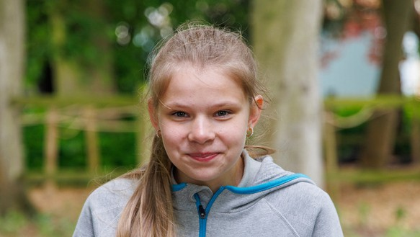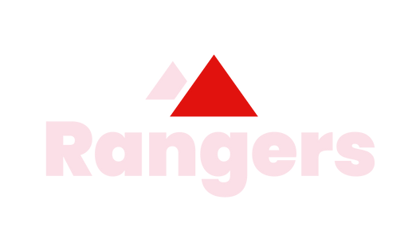

Insert county/region

# For ages 4 to 7

Rainbows welcomes all girls to come together to laugh, learn and have fun in a creative, safe space. It's a wonderful world of adventure, week after week, just for her.

Brownies is full of firsts: she can explore her creative side, get out into the great outdoors, learn how to look after herself, others and the world we live in.

# For ages 7 to 10

**For ages 10 to 14**

Guides is a fun-filled space, she'll have one big adventure with friends, learn how to be herself, explore the things she loves and do stuff she's never done before.

Rangers is an open and relaxed space, where you can regularly meet up, go on trips at home and abroad, to help make a difference to the things you care about.

# For ages 14 to 18

Find a group near you girlguiding-anglia.org.uk