# 'I had never climbed before. I was scared of heights. But I climbed and rang the bell all by myslef and felt really proud of myself'

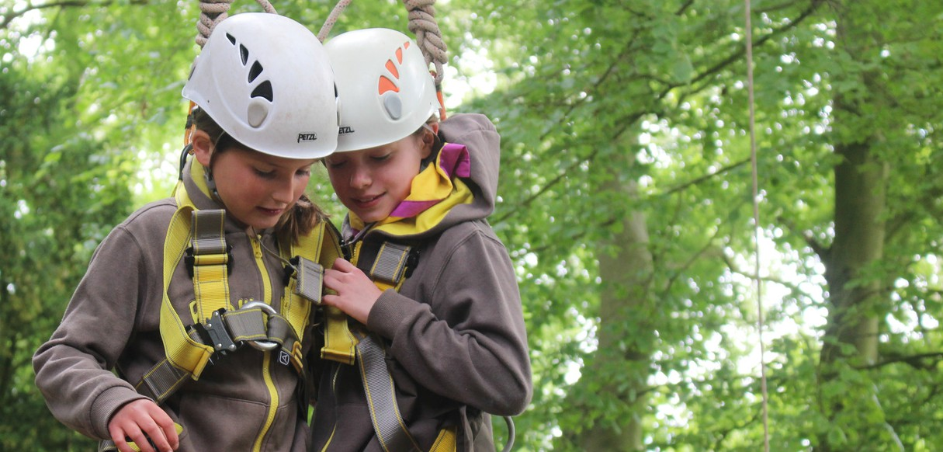

**Poonam**

Girls have nonstop fun, learning and adventure

**for ages 7 to 10**

At Brownies, we welcome all girls to explore their creative side, get into the great outdoors and start to learn to look after themselves, others and the world we live in.

Insert county/region

Join a local Brownies group girlguiding-anglia.org.uk