



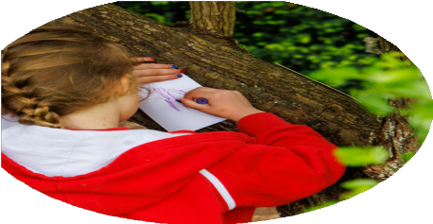
Insert county/region

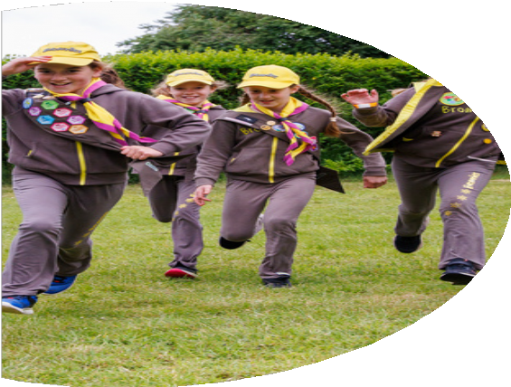
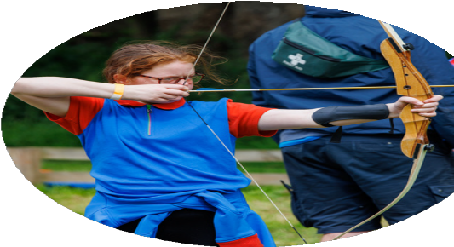



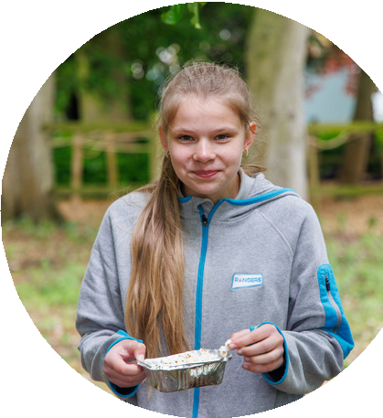


Welcome to your new home!

Looking to get to know your community?

Join a Girlguiding unit in your area!

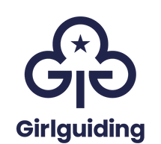

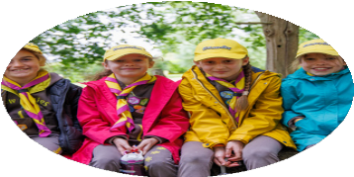
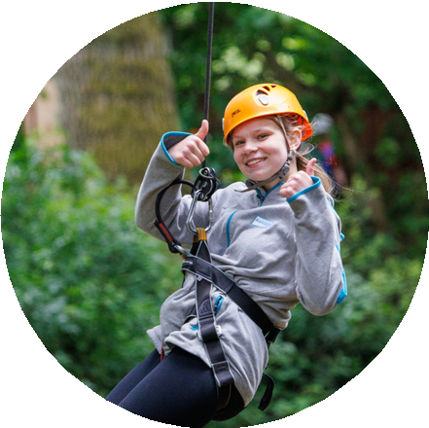
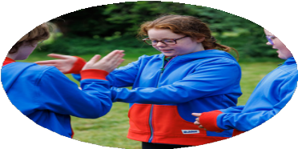

Insert county/region
Girlguiding offers a broad range of exciting activities and rewards to be a part of. Help be the change and showcase your daughter's voice, skills and talent.
We help all girls know they can do anything.

“At Rainbows we have done sports, races, painted sea creatures and swimming. Next I would like to have a water fight!” Isabella, 7,
Rainbow
“Our Leaders let us say what games we want to play and where we go on outings.” Tanis, 10,
Brownie
“Guides is the most adventurous thing, it gives you the opportunity to meet people and see things you wouldn't normally see, and it's a great experience.” - Bryony, Guide
“As exam season comes round quick every year, Rangers is a way to escape from the daily revision to just have a bit of “you” time and be a normal teenager.“ - Alice, Ranger

Are you interested to find out more?
Get in touch:

