
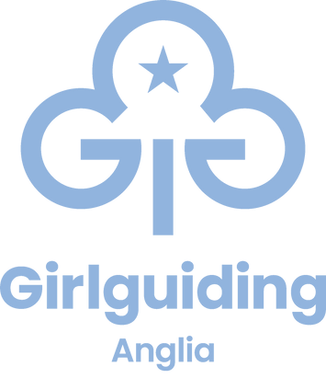
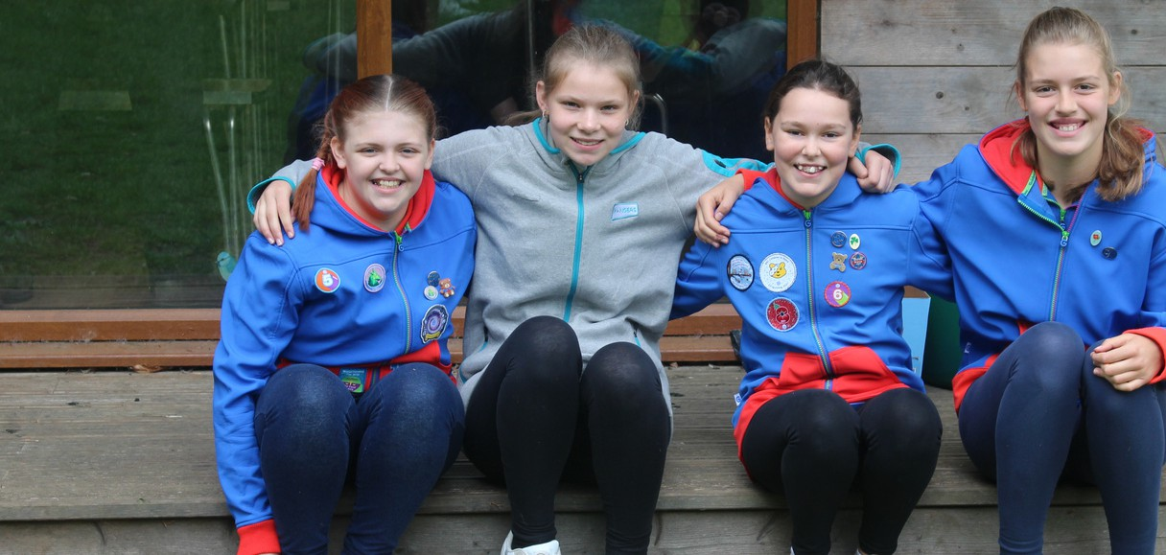

'Guides is the most adventurous thing... it gives you the opportunity to meet people and see things you wouldn't normally see, and it's just an amazing experience'

Bryony

Girls laugh, learn and expand their horizons
for ages 10 - 14
At Guides, all girls are welcome to enjoy our fun-filled space, where she'll make good friends, learn to be herself, explore what she loves and do stuff she's never done before

Insert county/region
Join a local Guides group girlguiding-anglia.org.uk

