'Guides is the most adventurous thing... it gives you the opportunity to meet people and see things you wouldn't normally see, and it's just an amazing experience'

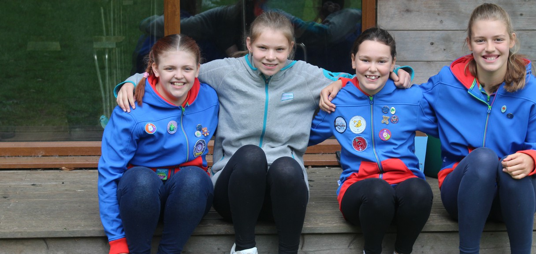

**Bryony**

Girls laugh, learn and expand their horizons

**for ages 10 - 14**

At Guides, all girls are welcome to enjoy our fun-filled space, where she'll make good friends, learn to be herself, explore what she loves and do stuff she's never done before

Insert county/region

**Join a local Guides group girlguiding-anglia.org.uk**