
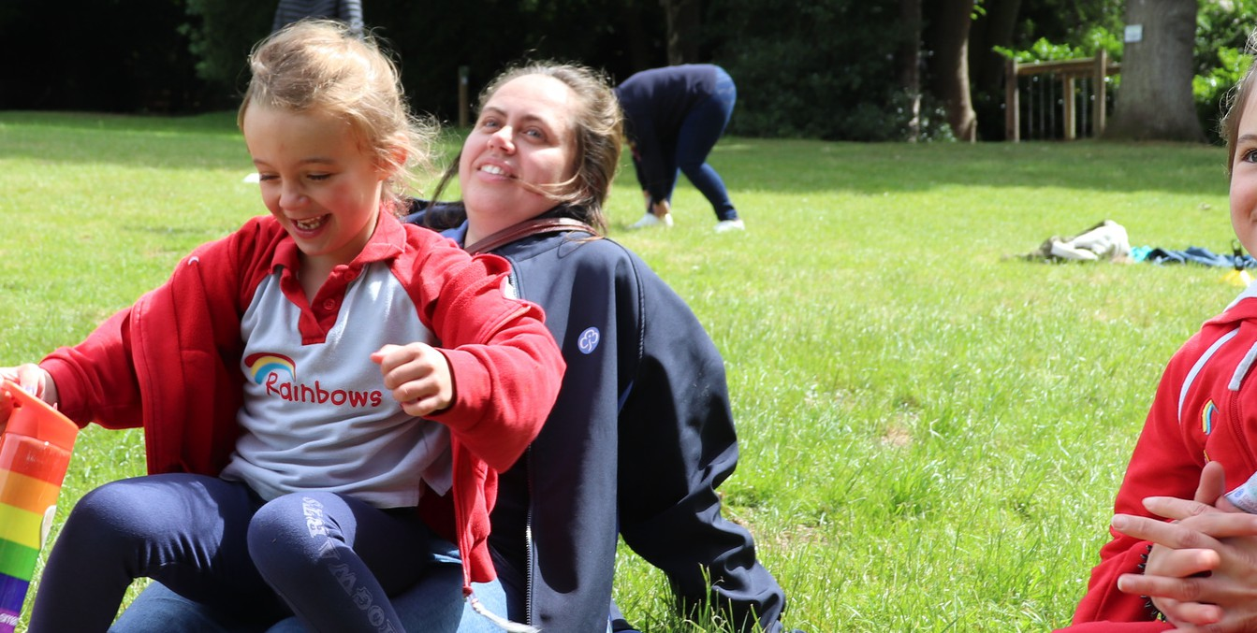


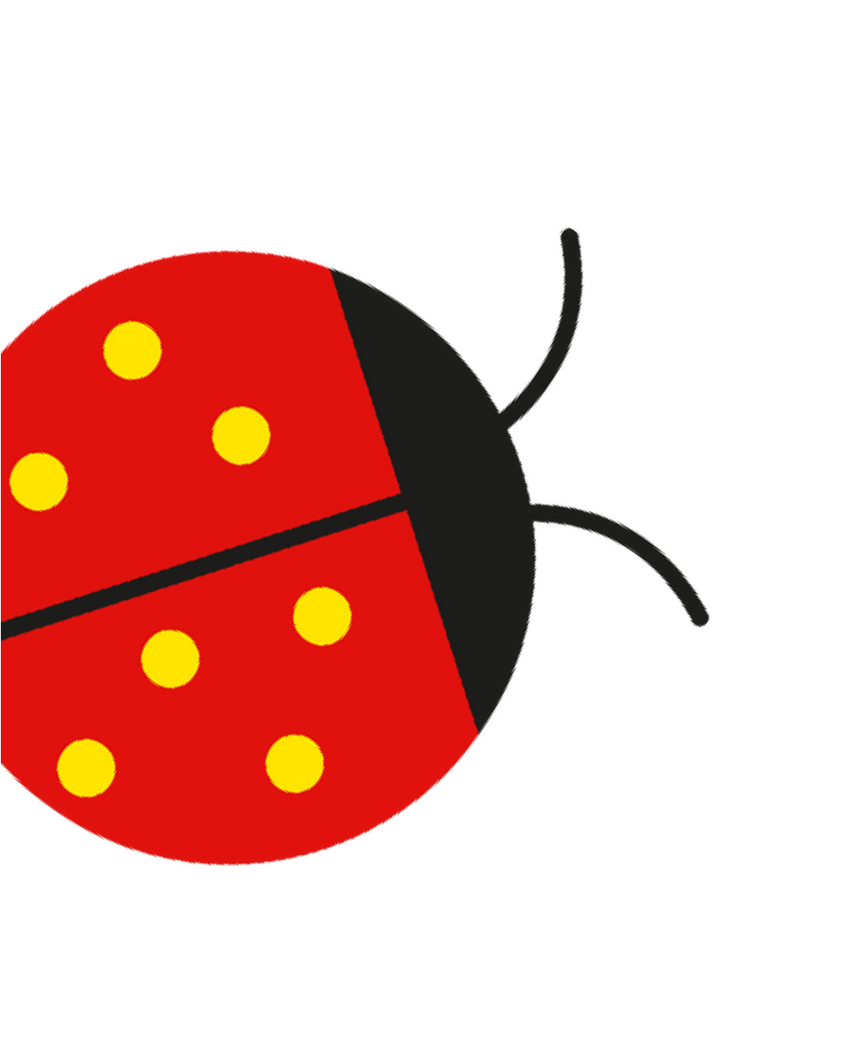



'We play loads of fun games, do activities and challenges and sometimes get badges'
Matilda

Girls play, learn and have tons of fun
for ages 4 to 7
At Rainbows, we welcome all girls to play, learn and have fun in a creative, safe space for all abilities.

Insert county/region

Join a local Rainbows group girlguiding-anglia.org.uk

