# 'We play loads of fun games, do activities and challenges and sometimes get badges'

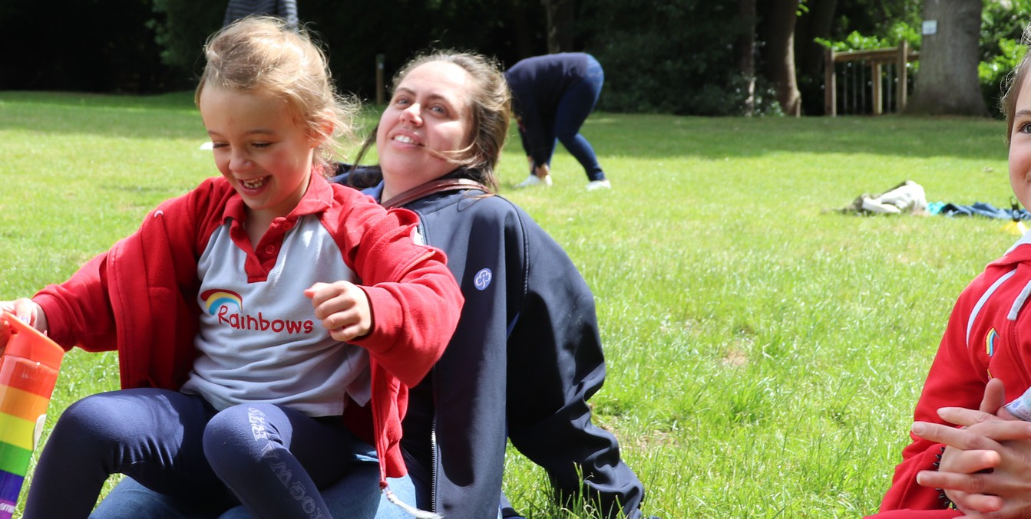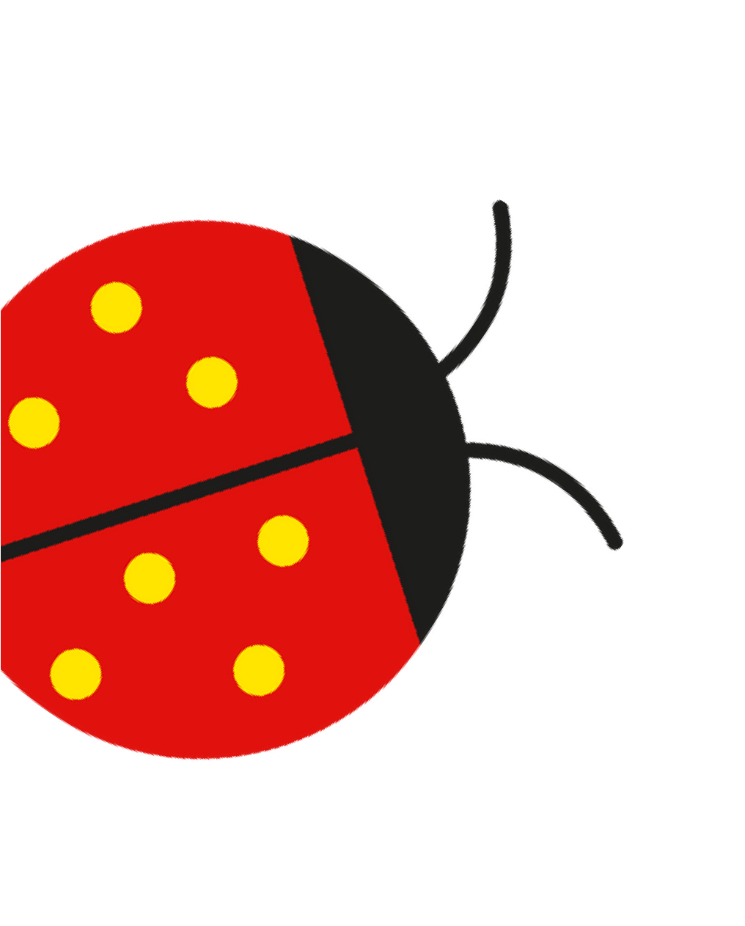

**Matilda**

Girls play, learn and have tons of fun

**for ages 4 to 7**

At Rainbows, we welcome all girls to play, learn and have fun in a creative, safe space for all abilities.

Insert county/region

Join a local Rainbows group girlguiding-anglia.org.uk