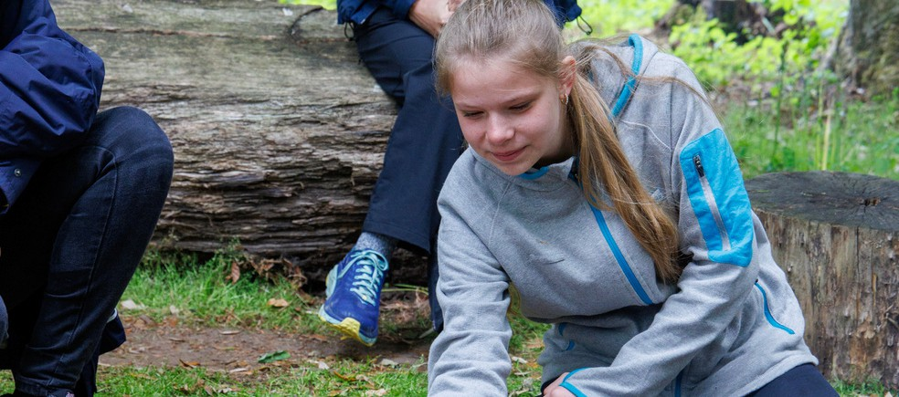




'It's about going out in the world and exploring stuff. It's given me an opportunity to do so much'
Daisy

Girls have fun, hangout, learn more and give back
for ages 14 to 18
Rangers is an open and relaxed space for you to regularly hangout with good friends and be yourself. You can go on trips at home and abroad, to help make a difference to the things you really care about.

Insert county/region
Join a local Rangers group girlguiding-anglia.org.uk

