'It's about going out in the world and exploring stuff. It's given me an opportunity to do so much'

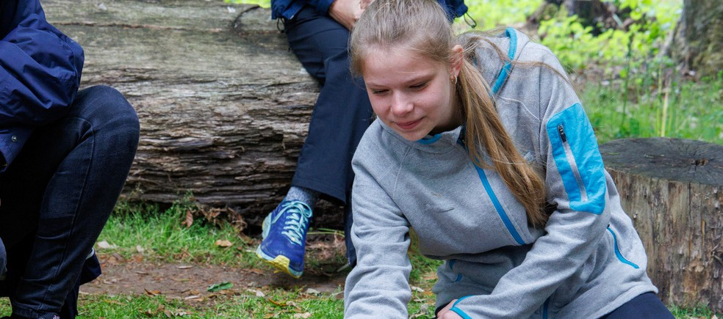

**Daisy**

Girls have fun, hangout, learn more and give back

**for ages 14 to 18**

Rangers is an open and relaxed space for you to regularly hangout with good friends and be yourself. You can go on trips at home and abroad, to help make a difference to the things you really care about.

Insert county/region

**Join a local Rangers group girlguiding-anglia.org.uk**