

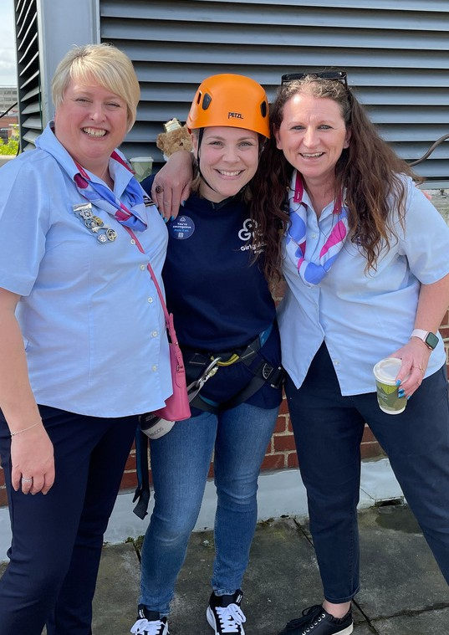

*County/region here*

You’re amazing...

Pass it on!

# Volunteer with Girlguiding Anglia

Volunteering with us isn’t just about campfires and helping girls to get their next badge - although those are special moments. It’s about empowering girls and giving them new experiences. It’s helping girls realise their own potential, sharing and developing your skills, all while having the time of your life.

# Join our growing family of volunteers

***Add website here***

Contact us:

*Add phone number here Add email address here Add social media here*