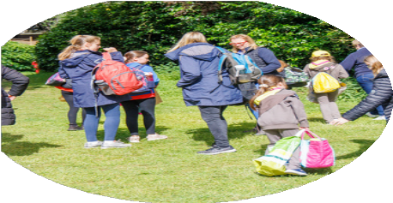

Insert county/region

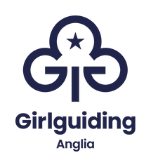

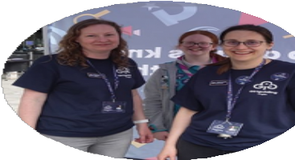Welcome to your new home!

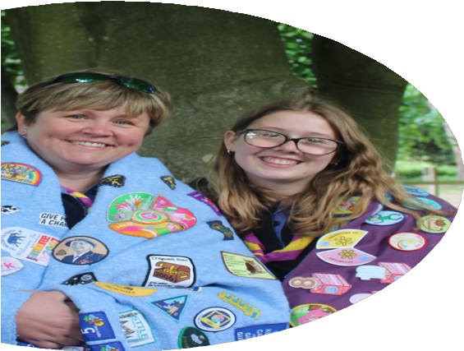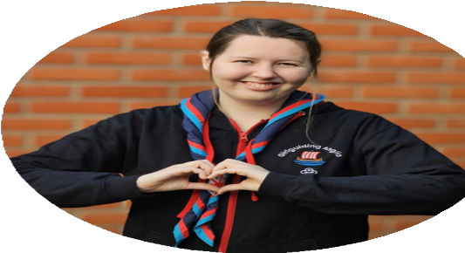

**Looking to get to know your community?**

Rainbows, Brownies, Guides, and Rangers units in the area are recruiting volunteers!





**We help all girls know they can do anything.**

Insert county/region

We show girls from 4 to 18 a world of possibilities big and small. One where every girl can laugh and learn and be herself.

Girlguiding is what each girl wants it to be. It might be the thrill of doing something for the first time. Songs around a campfire. The buzz of getting a new badge. Coming home exhausted and full of stories. It’s a space where she can be herself, get creative, explore, and most of all have fun.

**How can I get involved?**



You choose the volunteer role that matches your skills and time available. You can be a leader, a helper, a treasurer, a fundraiser, an administrator, a trainer, the list goes on and on…

# Are you interested

"We're awesome

as we help girls to thrive and grow because we are all part of a huge family"

**Volunteer, Bedfordshire**

# to find out more?

**Get in touch:**

*Insert social media handles here*

**You're amazing**

**Pass it on**

**Volunteer with Girlguiding Anglia**