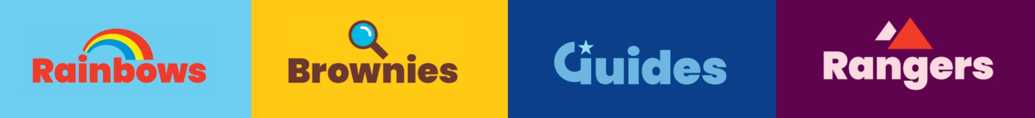

Insert county/region

Volunteers needed

**Share everything that’s awesome about you with the women of the future**

**Volunteer for Girlguiding and share everything that’s awesome about you with the women of the future.**

No matter how much time you have to give, there’s an opportunity for someone who’s as brilliant as you.

# **Who can volunteer?**

Anyone! There’s no requirement to have been involved in guiding before, and we’ve got lots of

opportunities for young people too.

# **How can I help?**

Whatever your skills and interests, whether it’s volunteering with girls directly or supporting behind the scenes, there’s a role to suit you.

# **What do we do?**

We offer a safe, girl-only space in which girls can build confidence, learn new skills and discover who they want to be. We’ve got an action-packed programme with an offer for every girl, Rainbows (4-7), Brownies (7-10), Guides (10-14) or Rangers (14-18), and we work to be truly girl-led in everything we do.

**“Volunteering is just about believing in yourself, being the best you can be. Being a leader has shown me more and more of that every day.”**



**To find out more about volunteering and to register, speak to your local leader, or visit girlguiding.org.uk/get-involved/become-a- volunteer/**

Emma, Queen’s Guide and assistant Rainbow Leader



Insert county/region

Insert county/region