Email templates for young volunteer enquiries.
Please note that all these emails should be sent to the enquirer and their parent/carer. Another Girlguiding volunteer should be copied in on all emails or other means of communication.

Initial email to 14-17 Year old enquiries
Send to enquirer and cc parent and another volunteer
Hi [enquirer name],
Thank you so much for signing up to volunteer with us for your Duke of Edinburgh’s Award. Girlguiding is a community of 70,000 volunteers who help make a difference to girls’ lives. and help all girls know they can do anything. I'm [Ann], and I volunteer responding to new enquiries in [Bedfordshire]. I’m here to help new volunteers like you find the right volunteer team, in your local area.
Based on the information you registered with, I understand you want to volunteer near [insert location]. Do you have a specific age group in mind? You can find out more here.
We have a great mix of units, each tailored to different age groups. They usually meet on weekday evenings, and here's a quick overview:
[Insert information about the units in your local area – section, age group, when and where they meet.]
Rainbows (4-7 yrs. old) –,
Brownies (7-10 yrs. old) –,
Guides (10-14 yrs. old) –

You can find out more about being a young volunteer with us to complete your DofE here - Young external volunteer | Girlguiding
Please let me know by replying to this email where you’re interested in volunteering and I’ll put you in touch with your local unit leader to arrange a visit to a unit meeting. Or if you prefer, we can have a call to talk through where you’d like to get involved.
Thanks again for reaching out and looking forward to chatting more.
Thanks,
[Your name]
[Your Girlguiding role]

Initial email to 13 year old enquiries
Send to enquirer and cc another volunteer. Request parent contact details.
Hi [enquirer name],
Thank you so much for signing up to volunteer with us for your Duke of Edinburgh Award. Girlguiding is a community of 70,000 volunteers who help make a difference to girls’ lives. and help all girls know they can do anything. I'm [Ann], and I volunteer responding to new enquiries in [Bedfordshire]. I’m here to help new volunteers like you find the right volunteer team, in your local area.
Based on the information you registered with I understand you want to volunteer near [insert location]. Do you have a specific age group in mind? You can find out more here.
We have a great mix of units, each tailored to different age groups. They usually meet on weekday evenings, and here's a quick overview:
[Insert information about the units in your local area – section, age group, when and where they meet.]
Rainbows (4-7 yrs. old) –,
Brownies (7-10 yrs. old) –,
Guides (10-14 yrs. old) –

You can find out more about being a young volunteer with us to complete your DofE here - Young external volunteer | Girlguiding
Please let me know by replying to this email where you’re interested in volunteering. Please copy in a parent or carer, so that we have their contact information. Then I’ll put you and your parent/carer in touch with your local unit leader to arrange a visit to a unit meeting. Or if you prefer, we can have a call to talk through where you’d like to get involved, please let me know a suitable time to call when you and your parent/carer are available.
Thanks again for reaching out and looking forward to chatting more.
Thanks,
[Your name]
[Your Girlguiding role]

Ending enquiry email under 17 year old enquiries
Send to enquirer and cc parent and another volunteer
Hi [enquirer name],
You recently enquired about volunteering with us. I sent you an introductory email and tried to contact you by phone/text, but I don’t seem to have had a response. As I haven’t heard back from you, I’ll have to end your enquiry with us and remove your details from our system so I can keep our enquiries list up to date.
If you’d like to enquire about volunteering again in the future, we’d love to hear from you again.
Warm regards,
[Your name]
[Your Girlguiding role]

Email if no suitable current opportunity available.
Send to enquirer and cc parent and another volunteer
Hi [enquirer name],
Following our emails and conversations about you volunteering with Girlguiding [Bedfordshire] for your DofE volunteering. At the moment we do not have any opportunities available in your area, as we currently have young volunteers completing their DofE volunteering service. We expect that there will be availability for you to volunteer with us from [Insert date or timescale]. Please can you reply to this email to indicate if you would be happy to wait for an opportunity to become available or not.
If you are happy to wait for an opportunity then I will contact you at that time.
If you no longer wish to volunteer with us, then do let me know and I will end your enquiry with us and remove your details from our system.
Please keep in mind that if I don't hear back from you, I may need to remove your enquiry from our system. However, if you ever decide to explore volunteering with Girlguiding in the future, I'd be delighted to welcome you onboard.
Thank you once again for your interest, [enquirer name]. We truly appreciate it. Feel free to respond to this email or give me a call at [phone number], and I'll be here to support you with any questions or next steps.
Warm regards,
[Your name]
[Your Girlguiding role]

Email to confirm young volunteer role for 14-17 year olds
Send to parent and cc young volunteer and unit leader volunteer.
Attach 14-17-years---new-starter-form.doc
Hi [enquirer parent/carer name]
I am happy to confirm that [enquirer name] will be volunteering with [Insert unit name] to complete DofE volunteering with us in the role of young external volunteer. There is more information here - Young external volunteer | Girlguiding
So that we have all the important information about [Insert name] and you have important information about volunteering with us, please can you complete the attached form. The completed form can either be returned electronically or as a printed copy to [name of unit leader] or to her local commissioner [name]. Both of whom are copied in on this email.
Your unit leader will share the young volunteer welcome leaflet with [Insert name] to introduce [her/him/them] to your unit and help [her/him/them] to set a goal for their volunteering time with us, complete tasks and reflect on your volunteering experience.
As part of starting this role, we need [her/him/them] to learn a little bit about keeping themselves and other people safe. This means that we’ll be asking [her/him/them] to undertake a safe space for young members e-learning.
This is an online learning module which covers roles and responsibilities, safeguarding and safety. We encourage you to take a look at it beforehand if you think it would be helpful. We will be following this up with a supportive conversation to check your child understands the content, can share any concerns and any support [she/he/they] needs can be put in place
[name of volunteer] there are instructions how to do this in your welcome email from Girlguiding. Follow the link to the login page and click the link to set up your login details. If you don’t have this email, just click here to go straight to GO and set up your details by following the above steps. Use the personal email address that you used when initially registering. You can find more information here.
The safe space training is completed on the learning platform, which you access with the same login details as for your GO account. Here is the link for the learning platform.
We hope [name of volunteer] enjoys [her/his/their] experience with us.
Thanks,
[Your name],
[Your Girlguiding role]

Email to confirm young volunteer role for 14-17 year olds
Send to parent and cc young volunteer and unit leader volunteer.
Attach 13-years-external-volunteer---new-starter-form.doc (live.com)
and creating-safe-spaces-together.pdf (girlguiding.org.uk)
Hi [enquirer parent/carer name]
I am happy to confirm that [enquirer name] will be volunteering with [Insert unit name] to complete DofE volunteering with us in the role of young external volunteer. There is more information here - Young external volunteer | Girlguiding
So that we have all the important information about [Insert name] and you have important information about volunteering with us, please can you complete the attached form. The completed form can either be returned electronically or as a printed copy to [name of unit leader] or to her local commissioner [name]. Both of whom are copied in on this email.
Your unit leader will share the young volunteer welcome leaflet with [Insert name] to introduce [her/him/them] to the unit and help [her/him/them] to set a goal for their volunteering time with us, complete tasks and reflect on their volunteering experience.
As part of starting this programme, we need [her/him/them] to learn a little bit about keeping themselves and other people safe. This means that we’ll be asking [her/him/them] to undertake some activities to think about:
- What makes others safe around you
- Information safety
- Their own wellbeing
- Identifying potential risks – either in a room, or in an activity
- What to do if someone needs help (let an adult know!)
The detailed activities are attached for you to look through.
We hope [name of volunteer] enjoys [her/his/their] experience with us.
Thanks,
[Your name]
[Your Girlguiding role]

Help file for finding parent/carer details on GO
At the time of writing (summer term 2024), parent/carer information is not visible on GO for 13 year old enquiries. For 14-17 year old enquiries you can find details by clicking Edit Individual. This action is only available in the commissioners zone whilst looking at All Volunteer Enquiries so if you have lots, you might like to filter by their name like so:

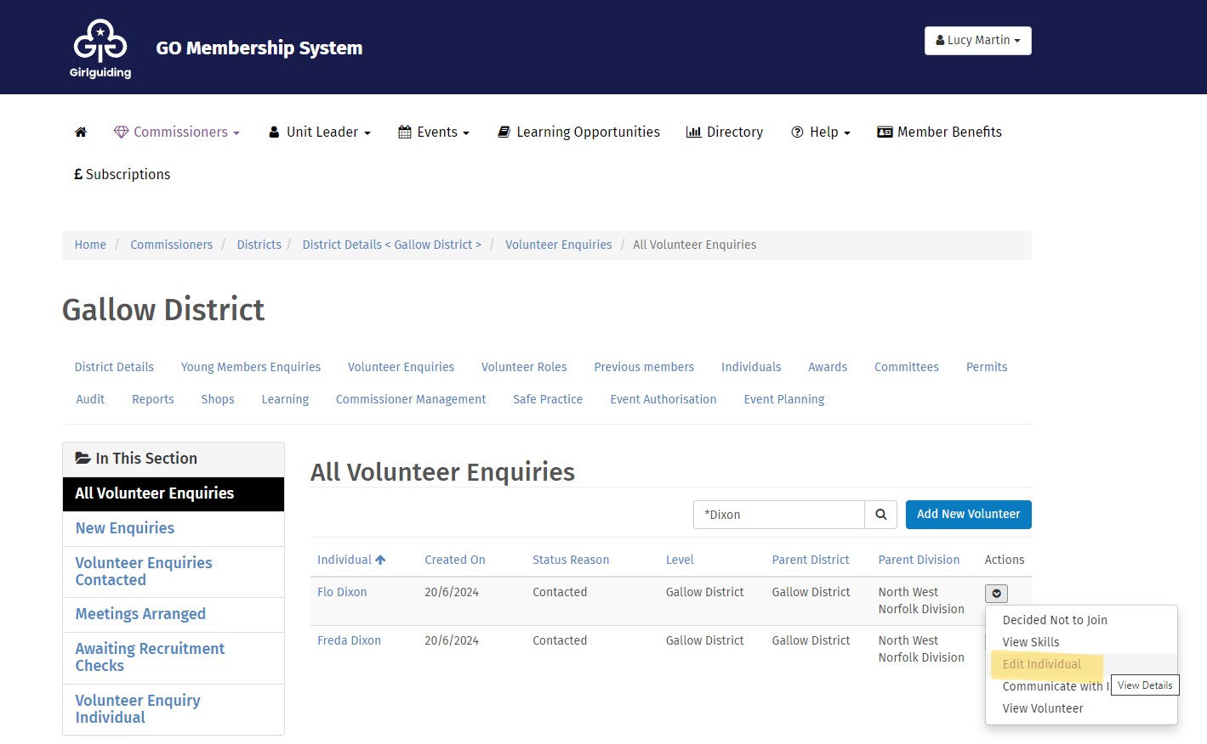

Scroll down the Edit Individuals page to the safe space training section. Next to this, you’ll see a section for parent/carer details that you can expand to find any contact details they shared when registering with us.

