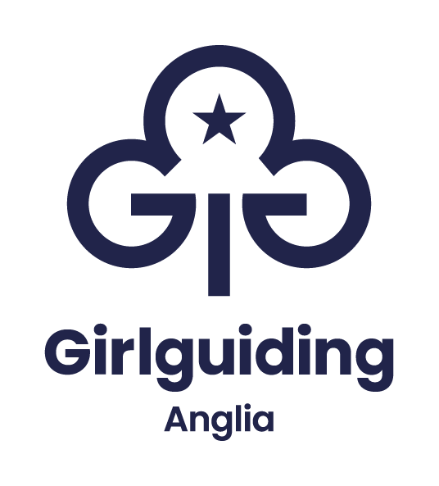

Application & information pack

Essex West county commissioner
Volunteer Role



Essex West county commissioner
Becoming a county commissioner in Girlguiding Anglia
Thank you for considering the county commissioner role. I appreciate that it might seem quite a daunting role to volunteer for, so below is a little more information that may be of use whilst thinking about this role.

What does the role involve?
Becoming a county commissioner is a fantastic opportunity to influence guiding in your area and create real change that improves opportunities for girls and young women. You'll be responsible for and accountable to the whole membership of the county. You’ll represent your county at region level and will be a really important part of helping to shape strategy and direction. You’ll see girls and volunteers develop their confidence and skills and giving members a voice. Plus, you’ll meet new people, challenge yourself and have fun, however you do not have to do it on your own. The full role description is attached.

How much time does it take?
This is probably the $50-million-dollar question! It really varies and depends on how you chose to build your team and delegate what needs to be done. There are a few things which have to be done by the county commissioner, but most parts of the role can be delegated to others with the county commissioner overseeing them. There is no set way to build your county team and what has worked for the current county commissioner might not be right for you and your circumstances, the skills that you bring to the role, and the needs of the county now.

Elements of the role which must be done by the county commissioner are:
• Being a trustee for your county. The county commissioner is usually the chair of trustees for the county and will need to lead regular meetings (often 4 – 6 a year) with the county team to ensure the appropriate management of finances and property (if applicable)
• Checking and approving residential event notifications (RENs)
• Representing your county at region (5 – 6 meetings a year)
• Leading your county team

What support would I receive?
There is lots of support available from different levels of Girlguiding. Nationally, you will be invited to take part in an induction training, plus attend regular county commissioner calls with the chief guide team and key staff from Girlguiding. In addition to this there are a range of training sessions available on the learning platform which are particularly relevant to commissioners.

From the region, we will give you a mentor who will help guide you through your first few months, plus a buddy who is a current county commissioner and will be a familiar face at your first region meeting!

We also have a very active WhatsApp group for all the county commissioners in the region which is used for airing and sharing queries. Finally, I; the rest of the chief commissioner team; and wider region team are all here to support you in your role. I am sure that you will also receive a lot of support from volunteers across your local area, from those who you already know and those that you are yet to meet.

We provide a full region induction and access to training throughout your appointment. You will be supported by dedicated members of the region office staff team, the region chief commissioner’s team and our executive manager.

How do I apply?
If this role interests you, and you would like to be considered for this role, please complete the application form and also ask your local commissioner to write in support of your application. You may also be nominated by other members in your county.

Please return the completed forms by 29 October 2025 to the details on the application form.

What happens next?
Once all applications have been received the chief commissioner and/or executive manager will contact you to discuss your application and the outcome or next steps.

Application form
Essex West county commissioner
Title & full name
Girlguiding membership no.:
Telephone number(s)
(indicate which is best to contact you on and when):
E-mail address:
Current role(s) within Girlguiding:
Please provide a personal statement detailing what you feel you could contribute to the role of county commissioner for which you are nominating yourself.

Please refer to the role information when describing the skills, you would bring / contribute to the committee.

Your statement should be no more than 750 words in total and should cover:
- the skills you possess
- your guiding experience and how this will assist you in this role
- other experiences outside of guiding (professional or voluntary) and how these would help you to fulfil this role
- why you would like to apply for this role
(Use an additional sheet as required).

Application form
Essex West county commissioner
Please complete the checklist below, and sign and date this form.

If you are completing the form electronically, please type your name in the signature box.

The deadline for applications is 29 October 2025

Interviews are scheduled for the 22/23 November 2025

All completed applications must be marked Private and Confidential and returned by e-mail or post to:

FAO: Ned Mead
Girlguiding Anglia Office
7 Great Hautbois Road
Coltishall, Norwich
NR12 7JN

Email: vacancies@girlguiding-anglia.org.uk

If you have any questions please contact the region office on 01603 737357 or via vacancies@girlguiding-anglia.org.uk

Checklist & declaration
_______________________________________________________
☐ I understand I am applying to become the county commissioner for Essex West and have understood the responsibilities that this entails.

☐ I am aware that my personal information will be shared:
- With the Anglia chief commissioner, and the executive manager.
- With the chief commissioner’s team.
- With the Anglia region office regarding administering the application process and supporting the successful applicant within the role.
_______________________________________________________

Signature:
Date:

Thank you for putting forward your application.

Supporting statement
Essex West County Commissioner

Title & full name of person completing this form:
Girlguiding membership no.:
Girlguiding role(s):

Telephone number(s)  (indicate which is best to contact you on and when): | Home:
 | Mobile:
E-mail address:
Supporting statement
Please tell us why you think the person nominating themselves would be suitable for the role (no more than 250 words):

Supporting statement
Essex West county commissioner

Supporting statement (continued):

Please return your supporting statement directly to Girlguiding Anglia (addresses below), not via the person nominating themselves.

The deadline for applications is 29 October 2025
All completed applications must be returned, marked Private and Confidential, by e-mail or post to:
FAO: Ned Mead
Girlguiding Anglia Office
7 Great Hautbois Road
Coltishall, Norwich
NR12 7JN

Email: vacancies@girlguiding-anglia.org.uk
If you have any questions please contact Ned Mead, PA and governance officer on 01603 737357 or via vacancies@girlguiding-anglia.org.uk

