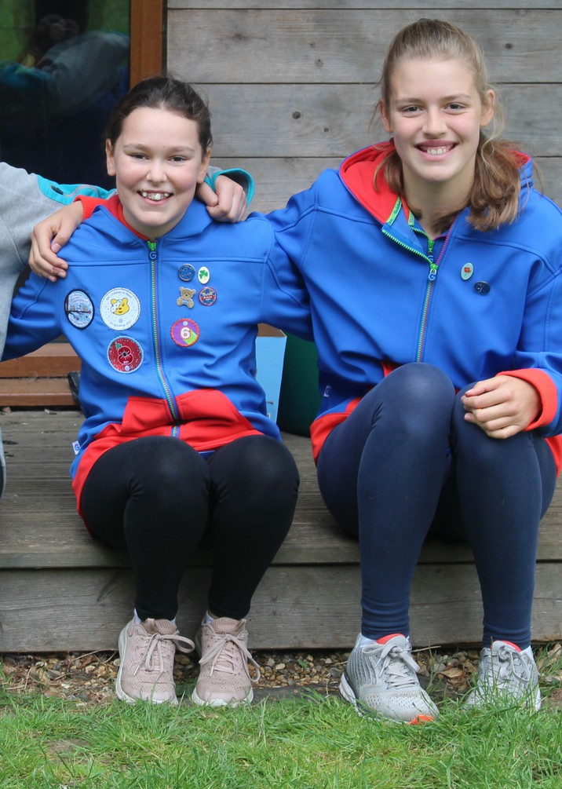

Girls laugh, learn and expand

their horizons

for ages 10 to 14

*County/unit here*

*Add website here*

*Add phone number here*

**Contact us:**

*Add email address here*

*Add Facebook here*

'You make so many new friends and it's just really fun and adventurous' **Bryony**