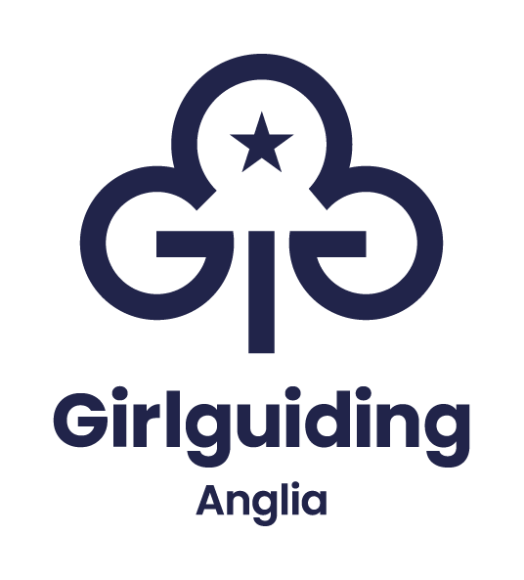

Information and application pack

Hautbois operations coordinator

Full-time, permanent
Salary £22,222

Based near Coltishall, Norwich
Hybrid working available, minimum 60% office based.

Closing date: Friday 16 January 2026

Overview

This operations coordinator role primarily focuses on supporting the senior centre and operations officer and senior leadership team to deliver the strategic priorities of Girlguiding Anglia. A passion for providing new experiences will be key for this role to enable the successful participant to support the events and Hautbois office manager and build resilience within the team.

The right candidate will have the opportunity to work collaboratively within a creative and forward-thinking environment, whilst also having the autonomy to complete regular tasks and projects. The job requires someone who enjoys a varied working day and thrives on managing diverse priorities and tasks positively and proactively.

When filling out the application if you feel there are some expectations you don’t have real-life experience of but instead have relevant transferrable skills that would enable you to thrive within this role, please still apply.

If you have any questions regarding this role and person specification or would like to discuss the opportunity further, please contact James Bowman at the contact details below:

For more information contact
James Bowman
James.bowman@hautbois.org.uk
01603 739696

Job Description

Post: Hautbois operations coordinator

Responsible to: Anglia executive committee and sub committees

Line management: Senior centre and operations manager

Purpose
As a member of the Hautbois operations team, you will work closely with the Hautbois centre manager to ensure the smooth and efficient delivery of operations. You will be responsible for overseeing day-to-day administrative tasks, as well as maintaining and developing key systems and processes.

Main duties for the post:
The duties are likely to vary so an ability to work flexibly will be essential.
To deliver admin support and a high-quality service as required, working closely with other members of the region team and volunteers.
The exact tasks will vary, and flexibility is key, but will include the following:
Administration
- Completing general office tasks including answering phone calls, joint management of shared inboxes, creating social media content and updating the region calendar
- Supporting with administration tasks including event bookings, member applications, managing databases and filing systems
- To ensure volunteers are fully supported and admin tasks are completed in a timely manner
- Follow brand guidelines and Girlguiding’s tone of voice, with producing letters, emails, social media posts and correspondence
- Extracting and presenting data clearly in Microsoft Excel
- Implementing and maintaining procedures and administrative systems
- Managing a diverse workload by using time management and prioritisation skills
- Set-up and take down of Hautbois events
- Engage with customers though social media in line with Girlguiding Anglia guidelines
- Work closely with the retail, communication and marketing team to produce flyers and other promotional materials in line with the brand guidelines for products and events
Customer care and liaison
- Occasional delivery of activity sessions on site
- Always maintain the highest of standards of customer care and communication
- Collect and collate feedback from customers, reporting back to the senior team
- Assisting with inductions and handovers of advisers and supporting them through a transition period
- Occasional attendance at evening meetings supporting lead volunteers to take minutes
- Any other duties which may be reasonably required within the role of operations coordinator
Additional information
- To be able to evidence Girlguiding’s values at all times, which underpin Girlguiding’s mission of ‘Being our best’
- Manage databases and filing systems
- Implementing and maintaining procedures and administrative systems
- Liaising with volunteers, staff, and external parties to contribute to effective internal and external communications
- Managing a diverse workload by using time management and prioritisation skills
- Miscellaneous tasks to develop the finance team, which will vary according to business priorities
- Maintain awareness and knowledge of issues related to the responsibility of this post and be responsible for personal development and updating on those issues of a professional nature
- Answer telephone enquiries and managing the central email inbox
- Deliver outstanding customer service internally and externally
- Ensure all work complies with GDPR and financial legislation and best practice
All Anglia region staff will be expected to:
- Build and maintain good working relationships with all colleagues and volunteers across Girlguiding
- Take reasonable care for the health and safety of self and others. Co-operate fully with the management of the company regarding Health and Safety legislation allowing that duty or requirement to be carried out or complied with
- Keep confidential all matters relating to Girlguiding Anglia in accordance with current legislation, including storage and release of digital information and data
- Ensure Girlguiding Anglia promotes a positive, professional image at all times
- Be an active team member, taking on additional responsibilities where appropriate to support others and promote excellent customer service
- Be able to evidence Girlguiding’s values at all times, which underpin Girlguiding’s mission of ‘being our best’
This role will require working some weekends with occasional weekday evenings, time off in lieu will be given.

Line Manager | Senior centre and operations manager
Working Hours | 35 hours per week
Location | Hautbois Activity Centre, Coltishall, Norfolk, NR12 7JN
Contract type | Permanent
Salary | Band A: £22,222

This is an outline job description designed to give an overview of the responsibilities of the role. We expect the job holder will work flexibly, responding to organisational needs and changes as they occur. You will also contribute to the wider corporate and organisational needs of Girlguiding Anglia.

We want everyone to feel comfortable and supported when applying to join Girlguiding Anglia. If you have a disability or think you might need any adjustments during the recruitment process, just get in touch with our HR officer at HR@girlguiding-anglia.org.uk
We are happy to discuss how we can best support you.

Person Specification

Factor | Essential | Desirable | Method of assessment
Education and qualifications | - Maths and English to level 2 or equivalent (GCSE grade C or above) | - Educated to higher education level or equivalent | Checking original certification
Experience: | - Managing high volumes of tasks.  - Excellent computer skills including experience of MS Office suite.  - Working to challenging deadlines | - Working with a wide range of different audiences  - Previous experience of administrative support and office procedures | Via application form and verified by references.  Through appropriate questions and answers at interview.
Ability to | - Demonstrate an understanding of and consistently working to the values of Girlguiding  - Demonstrate tact and diplomacy.  - Demonstrate discretion and handle confidential data appropriately, in line with GDPR regulations  - Be proactive and take the initiative.  - Manage own work priorities to meet deadlines  - Multitask and have good organisational skills  - Demonstrate good oral and written communication skills  - Work as a team member as well as on own initiative |  | Via application form and verified by references.  Through appropriate questions and answers at interview.
Knowledge of | - Excellent attention to detail  - Work flexibility and adapt priorities as priorities change  - Digital sharing platforms | - Adobe Professional Suite | Via application form and verified by references.  Through appropriate questions and answers at interview.
Committed to | - Joint working to achieve the overall aims of Girlguiding Anglia  - Supervision and appraisal  - Participation in team meetings and reflective discussions  - Strong positive focus on outstanding customer care  - Promoting Girlguiding Anglia and our services at all times |  | Via application form and verified by references.  Through appropriate questions and answers at interview.
Additional requirements | - Weekend and evening working as required |  | Checking original certification.  Via application form and interview.

Explanation
When completing the enclosed application form, please be aware that the person specification and cover letter will be used in determining the shortlist for interview. We welcome applicants at the beginning of their career and encourage you to apply even if feel your experience doesn’t meet every factor from the above person specification.

Only information provided by you on the application form can be used when making this decision.

Application form
Role applied for: Hautbois operations coordinator

Personal Details
First name(s)
Surname (family name)
Home Address (including postcode)
Contact details
Phone
Email

Declaration by applicant
I confirm that the information in this application form is correct. I understand that any false information or deliberate omissions which may impact upon or affect my ability to perform this role will disqualify me from employment or may render me liable for dismissal.

I agree that the information I have supplied can be stored digitally or held manually following UK General Data Protection Regulations.

I consent to Girlguiding Anglia (and their professional advisers) using and keeping information I have provided on this application form or elsewhere as part of the recruitment process and/or personal information supplied by third parties such as referees, relating to my application or future employment. The privacy notice can be viewed on Girlguiding Anglia’s website.

I understand that the information provided will be used to decide my suitability for employment and if successful the information will be used to form my personnel record and will be retained for the duration of my employment. If I am not successful, I understand that Girlguiding Anglia will retain my information for up to 6 months after which time it will be destroyed.

By submitting my application, I consent to all of the above.

Employment History
Starting with your present or most recent job, please give a summary of all employment, including any freelance and relevant unpaid/voluntary work. Please continue on another sheet if needed.

Present employment
Name and address of employer:

Dates of employment:

Job title:

Brief details of your responsibilities:
Notice required in current position:
Employment history
Name and address of employer:

Dates of employment:

Job title:

Brief details of your responsibilities:

Name and address of employer:

Dates of employment:

Job title:

Brief details of your responsibilities:

Name and address of employer:

Dates of employment:

Job title:

Brief details of your responsibilities:

Qualifications and training
Starting with the most recent, please give details of your education, qualifications and training relevant to this application.

Qualifications

Dates | Name of educational institution or training provider | Qualifications obtained including grades, and/or training relevant to the application

Training

Dates | Name of educational institution or training provider | Qualifications obtained including grades, and/or training relevant to the application

Please note, should you be offered employment we may ask you to provide evidence of relevant qualifications.

Skills, abilities, and experience
Using the job description and person specification please outline the skills, experience, and knowledge you have to deliver this role.

Final statement
Why would you like us to consider you for this role?

References
Please give the full details of two referees, including your present employer where applicable. Personal or academic referees should be given only when there is no previous employer to which reference can be made.

Reference 1
Name
Position
Telephone
Email
Relationship to you
Can references be taken up before the interview? |  | Yes/No

Reference 2
Name
Position
Telephone
Email
Relationship to you
Can references be taken up before the interview? |  | Yes/No

Other
Please tell us where you saw the role advertised
UK Work Restrictions
Are there any restrictions on you taking up employment in the UK? | Yes/No
Do you need a work permit to take up employment in the UK? | Yes/No

Return your application by:
Email to: hr@girlguiding-anglia.org.uk
Or by post, marked private and confidential to:
Vacancies at Girlguiding Anglia. 7 Great Hautbois Road, Coltishall, Norwich. NR12 7JN

Closing date for applications: Friday 16 January 2026
Should you not receive an acknowledgement within 48 working hours of sending your application please contact us at 01603 737 357 (option 1).

