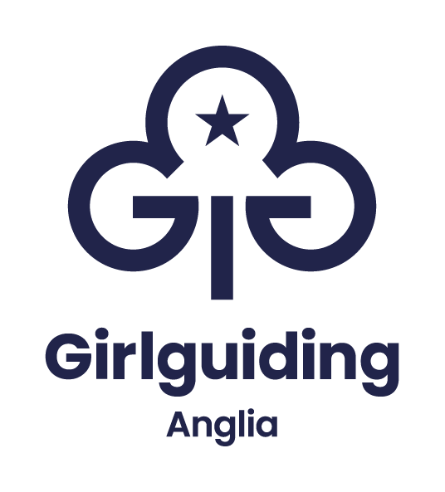

Information and application pack

Housekeeper

Part time
All hours considered
(please specify on application)

Based near Coltishall, Norwich
Hybrid working available, minimum 60% office based.

Closing date: Thursday 12 October 2023

Overview

Girlguiding Anglia is looking for housekeeper to join their team at the Hautbois activity centre. We are very flexible and happy to consider any number of hours you can work.
Based in the stunning Norfolk countryside, we are an expert provider of outdoor adventures and opportunities for learning and discovery for youth groups, schools and colleges, as well as corporate and private event bookings.
Indoor accommodation is provided at Hautbois House, a large twelve – bedroom house catering for residential groups of up to 59. In addition, we have campsites and a residential village with shepherd’s huts with a maximum capacity of 398 sleeps in total.
Occasionally there will be a degree of evening and weekend working to support with events.
We offer our team members free car parking, office drinks and snacks, increasing holiday allowance based on years’ service and modern IT and working facilities.
If you have any questions regarding this role and person specification or would like to discuss the opportunity further, please contact Rory Howard.

For more information contact
James Bowman
james.bowman@hautbois.org.uk

01603 737357 ext 211

Job Description

Post: Housekeeper

Responsible to: Hautbois Centre Manager

Line management: Hautbois Centre Officer

Purpose
To carry out all laundry and cleaning tasks as required to support Hautbois activity centre, its estate, campsite outbuildings and toilet blocks, and Anglia region office. To work closely with the Centre manager and deputy to ensure high standards of cleanliness and hygiene are met and maintained at all times.

Main duties for the post:
The duties are likely to vary so an ability to work flexibly will be essential.
Housekeeping Provision
• Clean all areas of the House in preparation for incoming guests, including preparation of beds, and maintain a high standard of cleanliness during their stay.
• Clean the Reedcutters cabins and dry shelter and the campsite dry shelters in preparation for incoming guests.
• Clean the campsite shower and WC blocks in preparation for incoming guests and maintain a high standard of cleanliness during their stay.
• Carry out all cleaning tasks for the office(s) including Anglia Region Office. This includes appropriate cleaning of IT and office equipment.
• Appropriately maintain special surfaces as required.
• Carry out regular deep cleaning, moving furniture to access areas beneath and behind them.
• Clean interior windows of Anglia Region Office and Hautbois regularly and as required.
• Carry out or assist with small maintenance jobs as required.
Health & Safety
• To ensure all health and safety regulations are strictly observed, including cleaning schedules, documentation and wearing of appropriate clothing.
• To ensure all necessary Health & Safety requirements are met with regard to COSHH, Manual Handling and other regulatory requirements.
• To ensure all housekeeping equipment is maintained in accordance with regulations and best practice.
• Maintain adequate stock control of cleaning materials.
• Maintain equipment and materials in a clean and safe working order, and ensure the laundry room, storage areas and guest accessible areas are tidy and organised.
To work with the Hautbois centre manager to ensure all COSHH information is up to date and stored appropriately.
Relationships
• Establish close and constructive working relationships with colleagues in the Catering and Housekeeping team and across the Hautbois Activity Centre staff team.
• Ensure tactful, diplomatic, positive, and constructive engagement with guests, contractors and suppliers.
• Instruct and assist other housekeeping staff members, temps and other occasional helpers in cleaning as required.
Other Areas
• To interact with customers appropriately as a customer facing member of the team.
• To answer the telephone and door to suppliers and guests and deal with them in a friendly, helpful, and polite manner.
• To assist the catering team and maintenance team as and when reasonably required.
All Anglia region office staff will be expected to:
- Build and maintain good working relationships with all colleagues and volunteers across Girlguiding
- Take reasonable care for the health and safety of self and others. Co-operate fully with the management of the company regarding Health and Safety legislation allowing that duty or requirement to be carried out or complied with
- Keep confidential all matters relating to Girlguiding Anglia in accordance with current legislation, including storage and release of digital information and data
- Ensure Girlguiding Anglia promotes a positive, professional image at all times
- Be an active team member, taking on additional responsibilities where appropriate to support others and promote excellent customer service
- Be able to evidence Girlguiding’s values at all times, which underpin Girlguiding’s mission of ‘being our best’

Additional information

This role will require working some weekends and weekday evenings, time off in lieu will be given.

Line Manager | James Bowman
Working Hours | Rotas are flexible to cover evenings and weekends as required. May include occasional split shifts during peak periods. Actual daily hours by arrangement.
Location | Hautbois Activity Centre, 5 Gt Hautbois Road, Coltishall, Norfolk, NR12 7JN
Contract type | Annualised hours
Salary | £12.21 per hour

This is an outline job description designed to give an overview of the responsibilities of the role. We expect the job holder will work flexibly, responding to organisational needs and changes as they occur. You will also contribute to the wider corporate and organisational needs of Girlguiding Anglia.

Person Specification

Factor | Essential | Desirable | Method of assessment
Education and qualifications | Good standard of literacy and numeracy including the ability to use a computer. |  | Via application form and verified by references.  Through appropriate questions and answers at interview.
Experience: | - An excellent understanding of Health & Safety and Regulations applying to housekeeping.  - Proven ability to work positively and constructively with staff and volunteers at all levels.  - Can use Microsoft Office Word and Excel to draft simple budgets and plans, and communicate effectively with suppliers, volunteers, and others. To keep records, and stock control.  - Proven ability of multi-tasking to meet deadlines.  - Proven experience of working within a small housekeeping team. | - Experience of housekeeping and working within a busy/fast paced environment. | Via application form and verified by references.  Through appropriate questions and answers at interview.
Knowledge and skills | - Proven ability to work on own initiative  - Ability to organise own time/workload and achieve deadlines  - Ability to assist the Housekeeping Co- ordinator with the administrative and regulatory needs of a kitchen environment, including stock control, ordering and time management. |  | Via application form and verified by references.  Through appropriate questions and answers at interview.
Additional requirements | - Conscientious, reliable  - Strong positive focus on customer care  - Highly flexible attitude to working patterns and workload  - Desire to provide a high standard of housekeeping service | - A knowledge of Girlguiding UK and a commitment to its statement of purpose  - Full Driving License | Via application form and verified by references.  Through appropriate questions and answers at interview.

Explanation
When completing the enclosed application form, please be aware that the person specification will be used in determining the shortlist for interview.
Only information provided by you on the application form can be used when making this decision.

Application form
Role applied for:
Hours applied for:
Personal Details
First name(s)
Surname (family name)
Home address (including postcode)
Contact details
Phone
Email

Declaration by applicant
I confirm that the information in this application form is correct. I understand that any false information or deliberate omissions which may impact upon or affect my ability to perform this role will disqualify me from employment or may render me liable for dismissal.

I agree that the information I have supplied can be stored digitally or held manually following UK General Data Protection Regulations.

I consent to Girlguiding Anglia (and their professional advisers) using and keeping information I have provided on this application form or elsewhere as part of the recruitment process and/or personal information supplied by third parties such as referees, relating to my application or future employment. The privacy notice can be viewed on Girlguiding Anglia’s website.

I understand that the information provided will be used to decide my suitability for employment and if successful the information will be used to form my personnel record and will be retained for the duration of my employment. If I am not successful, I understand that Girlguiding Anglia will retain my information for up to 6 months after which time it will be destroyed.

By submitting my application, I consent to all of the above.

Employment History
Starting with your present or most recent job, please give a summary of all employment, including any freelance and relevant unpaid/voluntary work. Please continue on another sheet if needed.

Present employment
Name and address of employer:

Dates of employment:

Job title:

Brief details of your responsibilities

Notice required in current position:
Employment history
Name and address of employer:

Dates of employment:

Job title:

Brief details of your responsibilities:

Name and address of employer:

Dates of employment:

Job title: Cleaner

Brief details of your responsibilities:

Name and address of employer:

Dates of employment:

Job title:

Brief details of your responsibilities:

Qualifications and training
Starting with the most recent, please give details of your education, qualifications and training relevant to this application.

Qualifications

Dates | Name of educational institution or training provider | Qualifications obtained including grades, and/or training relevant to the application

Training

Dates | Name of educational institution or training provider | Qualifications obtained including grades, and/or training relevant to the application

Please note, should you be offered employment we may ask you to provide evidence of relevant qualifications.

Skills, abilities, and experience
Using the job description and person specification please outline the skills, experience, and knowledge you have to deliver this role.

Final statement
Why would you like us to consider you for this role?

References
Please give the full details of two referees, including your present employer where applicable. Personal or academic referees should be given only when there is no previous employer to which reference can be made.

Reference 1
Name
Position
Telephone
Email
Relationship to you
Can references be taken up before the interview?

Reference 2
Name
Position
Telephone
Email
Relationship to you
Can references be taken up before the interview?

Other
Please tell us where you saw the role advertised
UK Work Restrictions
Are there any restrictions on you taking up employment in the UK?
Do you need a work permit to take up employment in the UK?

Return your application by:
Email to: hr@girlguiding-anglia.org.uk
Or by post, marked private and confidential to:
Vacancies at Girlguiding Anglia. 7 Great Hautbois Road, Coltishall, Norwich. NR12 7JN

Closing date for applications: Sunday 30 November 2025 at 23:59.

Should you not receive an acknowledgement within 48 working hours of sending your application please contact us at 01603 737 357 (option 1).

Equality and Diversity Monitoring
Girlguiding Anglia wants to meet the aims and commitments set out in its equality policy. This includes not discriminating under the Equality Act 2010.

We want everyone to feel comfortable and supported when applying to join Girlguiding Anglia. If you have a disability or think you might need any adjustments during the recruitment process, just get in touch with our HR officer at HR@girlguiding-anglia.org.uk
We are happy to discuss how we can best support you.

