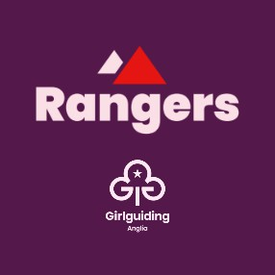

As you are now approaching 14, you may be aware that you will soon be able to move up to the next section in Girlguiding called Rangers.
Some Guides are ready and want to move straight away, others may prefer to wait an extra term or two. There is no expectation to move up before you feel ready, but Rangers gives you more freedom to choose and run your own programme and the opportunity to take part in a wider range of activities.
At 14 there is also the option to become a young leader with a Rainbow, Brownie or Guide unit which we are happy to discuss this with you and your parent or carer.
Below is a list of local Ranger units and their meeting details. If you would like to try a taster session at any of these units we can help arrange this for you. Some of the units may have waiting lists, but we can add your details to as many lists as you would like giving you the most choice when spaces become available. If none of these is suitable please speak to us and we can discuss alternative options.
We hope you have enjoyed your time with Guides so far and look forward to seeing your continuing adventures in guiding.
Yours in guiding, [Insert name]

Unit name:
Meeting day and time:
Meeting location:

Unit name:
Meeting day and time:
Meeting location:

