

Anglia new unit grant
Guidelines and application form

Contents
Grant guidelines 1
Items covered by the grant 2
What you cannot claim for 2
Contact 3
Application form – unit details 4
Application form – resource list 5
Application form – rent / licence support 6
Application form – payment details 7
Application form – checklist 7
Declaration by local commissioner 8

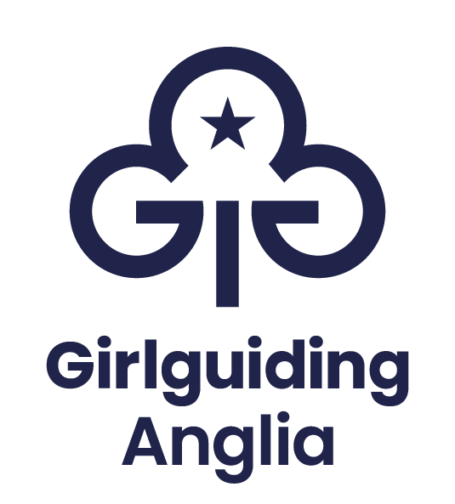

Grant guidelines
Please read these guidelines carefully, including the check list, before completing the application form.
The Anglia new unit grant is available for new units to apply for a maximum of £250 to provide support in the delivery of the Girlguiding programme and a maximum of £120 to support the first 6-meetings rent or 3 months online meeting platform licence costs.
This can be applied for in addition to other grant funds and is compatible with The Trefoil Guild starter pack. External local community funds may also be available.
This application form can be completed by the unit leader, treasurer, or local commissioner. A commissioner at least a level above the applicant must countersign the application. If the signatory is not your county commissioner, they will be informed of your application before payment is made.
You must apply for the grant 90 days before or after the unit’s ‘formed date’ on GO (your unit’s first meeting). Applications received before this time will be held and after this time may not be processed. If reopening a unit with an earlier ‘formed date’ please speak to a member of the team to check you are eligible.
From receipt we aim to process your application within 30 days.
You do not need to have set up the unit bank account to apply for the grant. Funds can be paid into a district or division account; they cannot be paid into a personal account. If items are purchased direct from the Girlguiding Anglia shop, we can organise a direct payment of the unit invoice.
You will need to provide a unit budget based on the first 6-months of operation alongside your application. Information on budgeting is available from the Girlguiding website.
If re-opening a previously closed unit a copy of the final financial summary, including assets and liabilities, will also need to be provided.
Receipts for the total amount or more must be received within 6 months of the grant being paid. Any underspend must be returned to Girlguiding Anglia within 9 months of the grant being paid.
We may contact you within 12 months of the grant payment date to ask for your feedback.
The grant is only available to units registered within the Anglia region.

Items covered by the grant
Applications will be considered to a maximum of £250 for:
- Promise badges and certificates for registered leaders and girls
- Official Girlguiding badge books for registered girls
- Volunteer uniform (maximum 1 item per leader, young leader or unit helper)
- Unit meeting activities and skills builder packs printing relevant to the section(s)
Additionally, the following can be applied for to a maximum of £120:
- Rent (actual) for the first 6-meetings or
- Licence fees for a virtual meeting platform equivalent to the first 3 months.
Note: Registered means a member who has an active role, active pending role or is on the waiting list to join the unit on the day it opens. We regret that we cannot fund girls who join after the unit has already opened as these are considered running costs and not start-up costs.

What you cannot claim for
It does not cover:
- Additional badges to those described
- Non-uniform guiding wear for girls or young women
- Activity items outside of the official Girlguiding unit meeting activity packs and skills builder packs.
- A unit that is re-opening where the previous unit has been closed for less than 6 months.
- Units outside the Anglia region
- Items already funded by other grants
We cannot fund for more than the suggested maximum recommended number of girls in a unit (see the adult to child ratios on the Girlguiding website)

Contact
Should you have any questions prior to or whilst completing this application please contact the membership support team at the Anglia region office.
Once you have completed the application form and had it signed by the relevant commissioner, please return the documents to the region office by email or post, keeping a copy for your own financial records.
Email: hello@girlguiding-anglia.org.uk
Phone: 01603 737357, option 1
Address: Member support, Girlguiding Anglia, 7 Great Hautbois Road, Coltishall,
Norfolk. NR12 7JN

Application form – unit details
For completion by the unit leader, treasurer, or local commissioner. A commissioner a level above the applicant must countersign the application.
Information provided should match the information available on the GO database.
Name of unit:
Unit level number:
Expected opening date:
Post code of unit meeting place:
Applicant’s name:
Applicant’s membership number:
Applicant’s role in relation to new unit:
Why are you starting a new unit?
☐ No units in an area where there is demand or potential demand from girls.
☐ All local units are full and have lists of girls waiting to join.
☐ A new community with lots of families moving in at the same time.
☐ Other (please specify)

How many girls/young women are active in the unit?
(For a girl to be considered ‘active’ she must have a record on GO and be included as an active member or be on the waiting-to-join or waiting-to-transfer list.)

How many active adult leaders, young leaders and unit helpers are there?
(For an adult to be considered ‘active’ she must be on GO with a unit role.)

Are you re-opening a unit which has been previously made inactive? |  |  | ☐ Yes ☐ No
If yes, when was the unit made inactive?

If yes, why was the unit made inactive?

Are there any funds or resources remaining from the inactive unit?  If yes, please attach a copy of the final financial summary including assets and liabilities. |  |  | ☐ Yes ☐ No
What other funding have you applied for? (Please specify sources and amounts)

Application form – resource list
Complete the resource list based on the number of girls/young women and leaders previously stated in your application.
For information on available items and prices please speak to your local depot volunteer, visit the Girlguiding Anglia shop website, or call and speak to a member of the Anglia retail team, 01603 737357 Option 3.
Item | Number / list items | Request in £
Promise badges and certificates
(leaders and/or young members)
Official Girlguiding badge books relevant to section (leaders and/or young members)
Leader uniform
(Maximum 1 item per leader, young leader or unit helper) Please state individual items
Printing costs for unit meeting activity (UMA) packs
(Please breakdown cost)
Printing for skills builder packs
(Please breakdown cost)
Themed display books for UMA and skills builder packs
Total funding requested (max £250):

Application form – rent / licence support
Rent / licence support | Request in £
Rent to the equivalent of 6 meetings (an invoice or official statement of rental amount will be required)
Licence fees for a virtual meeting platform equivalent to the first 3 months (confirmation of purchase and cost will be required)
Total funding requested (max £120):

Application form – payment details
Payment will be made by bank transfer. Please provide the following information:
I understand I will need to provide evidence of spend within 6 months of receiving the money.
Account name:
Account number:
Sort-code:

Application form – checklist
Please check this list before submitting the form.
☐ Your unit is registered on GO as an active unit.
☐ Your application is made within 90 days of your unit first meeting.
☐ All details of members, including those who are active, active-pending or waiting-to-join, are registered under the unit on GO.
☐ You have listed a breakdown of items requested.
☐ You have included/attached a budget summary for the first 6 months of the unit.
☐ You have included/attached an invoice or official letter stating the rental or virtual platform amount.
☐ Your local commissioner has countersigned the application.

Declaration by applicant
I, ____________________________________________, confirm that, if granted, the monies will be used for the stated purpose as allocated, or returned to Girlguiding Anglia within 9 months of the date of issue.
Signed:__________________________________________
Date: ______________________

Declaration by local commissioner
Please note that if you are the local commissioner or related to the applicant you should pass to your next-level commissioner for completion.
I, ________________________________________, have checked this application, support it, and can confirm that:
- There is evidence of need for this unit
- The application details are accurate
- I will ensure that this funding is used for the purpose stated
- I am not related to the applicant
Membership number: _________________________
Signed: __________________________________________
Date: ____________________

Once you have completed the application form and had it signed by a relevant commissioner, please return the documents to the region office by email or post using the contact details on page 3.
It may be useful to retain a copy of the application for your own financial records and in case of any queries.

