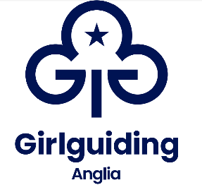**Girlguiding Anglia peer educator application form**

**Training dates**: 26-28 September 2025

**Training venue**: Hautbois Activity Centre, 5 Great Hautbois Rd, Coltishall, Norwich NR12 7JN

**Training topic:** Think Resilient - gives girls  the tools to build their mental well-being. Developed with YoungMinds

*Attending the training is free of charge. Travel expenses will be reimbursed by your county.*

|  |  |
| --- | --- |
| Name: | Membership no: |
| DoB: | Age at training: |
| Current role in guiding: | County: |
| Email address: | |
| Contact phone number: | |

If under 18:

|  |
| --- |
| Parent/carer full name: |
| Parent/carer email address: |
| Parent/carer contact number: |
| Please tick: ( ) I confirm that I have permission from my parent/carer to apply for this role. |

Reference from a Girlguiding leader or commissioner who works with you regularly

|  |  |
| --- | --- |
| Name of referee: |  |
| Role in guiding: |  |
| Membership number: |  |
| How long have they known you? |  |
| Please insert reference here (maximum 500 words) | |

Please answer the following three questions to help us determine whether becoming a peer educator is the right opportunity for you in guiding at this point in time.

|  |  |
| --- | --- |
| Why do you want to be a peer educator? (maximum 200 words) |  |
| Tell us about a time you have demonstrated leadership skills. (maximum 200 words) |  |
| Peer educators train on a variety of topics. If you could choose, what would the next peer education topic be? (maximum 200 words) |  |

*Delete as appropriate:*

I **am/am not** available for the peer education basic and topic training to be held in Hautbois 26-28 September 2025.

If I am not initially selected for the September 2025 training, I **would/would not** like to be put on the waiting list for the 2026 training (date to be decided), if a space becomes available.

Signature of applicant:

Date:

Please send this form to your county peer education coordinator or to [angliapeered@girlguiding-anglia.org.uk](mailto:angliapeered@girlguiding-anglia.org.uk) by Monday 14 July 2025.

You will receive email notification when we receive your application, and an update on its status by Monday 21 July 2025 at the latest.

Further information can be found about Peer Education online here <https://www.girlguiding.org.uk/information-for-volunteers/programme-and-activities/peer-education/>