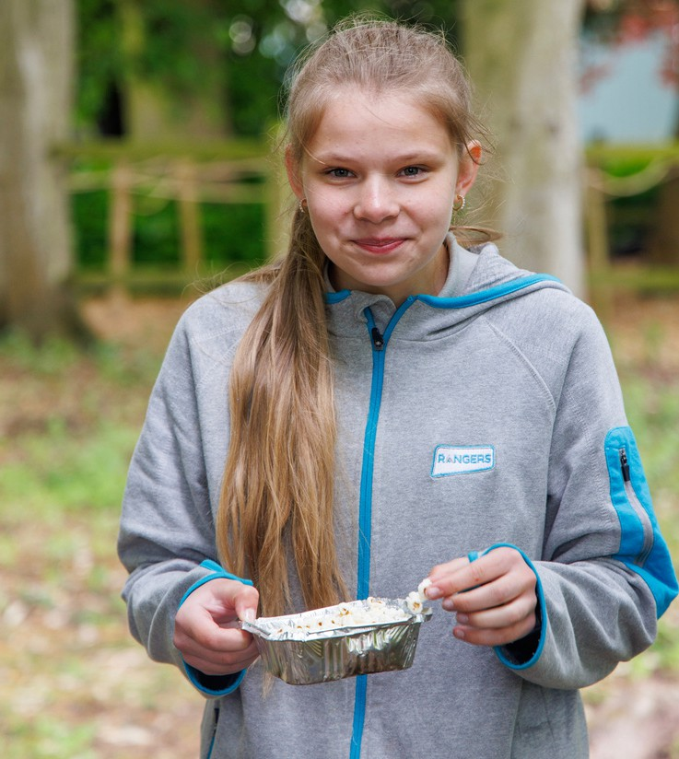





Girls have fun, hangout, learn more and give back
Contact us:
Add website here
Add phone number here
for ages 14 to 18
Add Facebook here
Add email address here
'I would never have spoken in front of a crowd before, but Girlguiding has definitely improved my confidence'
Kashina
County/unit here

