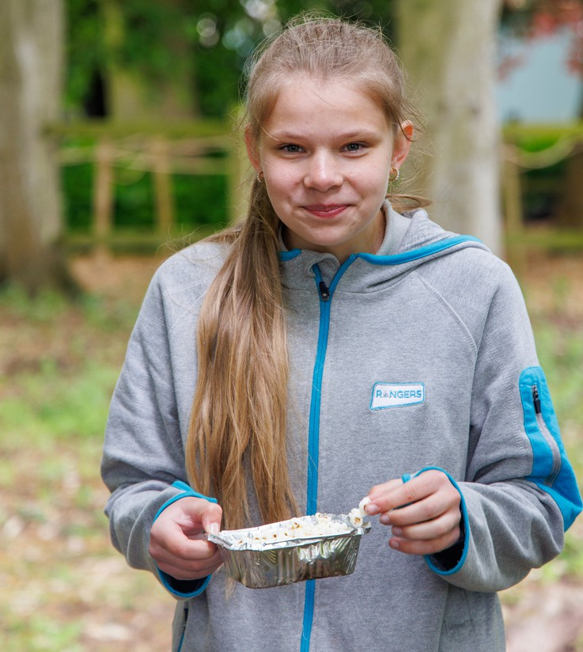

Girls have fun, hangout, learn more and give back

**Contact us:**

*Add website here*

*Add phone number here*

for ages 14 to 18

*Add Facebook here*

*Add email address here*

'I would never have spoken in front of a crowd before, but Girlguiding has definitely improved my confidence'

**Kashina**

*County/unit here*