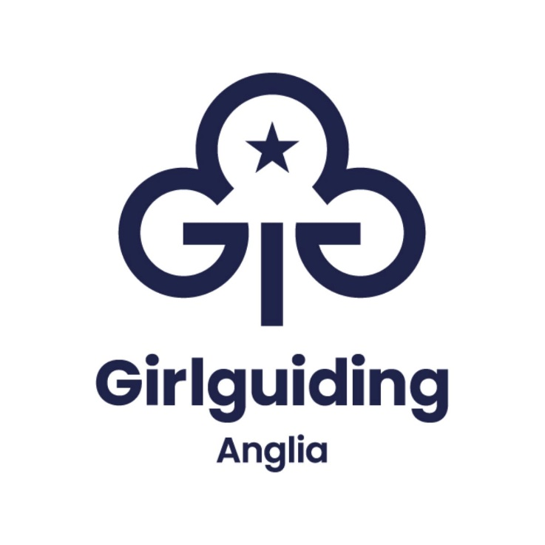

Whistleblowing Policy
Ratified: | July 2024
Next Review: | 2027
Applicable to: | Staff, Volunteers, Contractors
Chairs signature: | N Record

CONTENTS

1. | Summary | 3
2. | What is the procedure if an employee has a concern? | 4
3. | What are the line manager’s responsibilities? | 4
4. | Who are the designated senior managers and what is their role? | 5
5. | What are the designated senior manager's responsibilities? | 5
6. | How should investigations be conducted? | 5
7. | When a concern is raised, is the employee entitled to representation? | 6
8. | How should these meetings be managed? | 6
9. | What actions should be taken after the meeting? | 7
10. | What happens if an employee is dissatisfied with the outcome of an investigation? | 7
11. | What happens if someone approaches an employee with concerns over malpractice? | 8
12. | Further information and external advice | 8
13. | Whistleblowing procedure

- Summary

This policy applies to all employees, volunteers and other workers performing functions in relation to the organisation, such as contractors, consultants, agency, casual, volunteer workers or trustees and committee members who are not in Guiding. Girlguiding Anglia takes all concerns seriously and if an employee or other worker wishes to raise a serious concern regards a volunteer, the Girlguiding Anglia Volunteer whistleblowing procedure will be followed. For more information please access the Girlguiding website.

It is important to the business that any fraud, misconduct or wrongdoing by employees of the organisation is reported and properly dealt with. The organisation therefore encourages all employees to raise any concerns that they may have about the conduct of others in the organisation, or the way in which the organisation is run. This policy sets out the way in which employees may raise any concerns that they have and how those concerns will be dealt with.

The Public Interest Disclosures Act 1998 aims to protect workers from victimisation and dismissal when they raise genuine concerns about misconduct and malpractice such as:
- a criminal offence
- a failure to comply with a legal obligation or regulatory requirements
- a miscarriage of justice
- danger to the health and safety of any individual
- damage to the environment
- bribery
- financial fraud or mismanagement
- negligence
- an attempt to conceal any of the above

It is not necessary for the employee to have proof that such an act is being, has been, or is likely to be, committed. A reasonable belief or genuine concern is sufficient for a report to be made under this policy. The employee has no responsibility for investigating the matter, it is the organisation’s responsibility to ensure that an investigation takes place.

The policy directs employees towards raising issues internally, reflects good employment practice and encourages openness, accountability and integrity.

- What is the procedure if an employee has a concern?

This procedure is for disclosures about matters other than a breach of an employee's own contract of employment. If an employee is concerned that their own contract has been, or is likely to be, broken, they should use the organisation’s grievance procedure.

If an employee has a concern, they should first approach their line manager and request a confidential meeting to discuss the issue.
It is not necessary for the employee to show that a relevant act or omission has taken place, only that they reasonably believe one has/or is about to take place.

If it is not possible for the employee to speak to their line manager, for example because they think their line manager might be involved, they should refer the matter to another line manager, the manager to whom their line manager reports, executive manager or chair of trustees. Before embarking on any further action, the line manager must contact the executive manager or the chair of Anglia HRC for guidance and advice.

- What are the line manager’s responsibilities?

The line manager should arrange a meeting with the employee at an appropriate time and place and ask them to confirm the basis of their concern, including names, dates and places where possible and why they believe wrongdoing has / is taking place, or is likely to take place.

The line manager will be responsible for determining what action, if any, is required. This will normally be one of the following three options:
- Arrange for the matter to be investigated further if appropriate.
- If the matter is more serious or outside their remit, refer it to either a member of the senior leadership team, executive manager or chair of Anglia HRC referred to as the designated senior manager.
- Inform the employee that, after consideration, there is no cause for their concerns and no further action will be taken.

Whatever the decision, the line manager will inform the employee within ten working days of the meeting how the allegations will be dealt with.

- Who are the designated senior managers and what is their role?

All senior leadership team members are designated points of contact for:

- employees who are dissatisfied with the response given to concerns raised with their line manager (or next higher manager),
- those who feel unable to report their concerns due to fear of victimisation,
- line managers who are unable to deal with the concerns raised because the matter is serious or outside their remit.

There are no restrictions as to the type of concerns dealt with by a designated manager, and employees or managers with concerns should contact the person they feel to be most appropriate.

The designated senior managers role is to always maintain confidentially of the whistleblower.

- What are the designated senior manager's responsibilities?

Where concerns are raised with a designated senior manager (either directly by the employee or on the referral of a line manager), they will arrange an interview with the employee to ascertain the area of concern.

- How should investigations be conducted?

Any investigation will be conducted confidentially, particularly in cases of suspected fraud. In certain cases, consideration will be given to suspend the employee who is alleged to have done wrongdoing.
The designated senior manager will inform the employee who is investigated of the outcome of any investigation or, if no investigation is deemed necessary the reason for this, within ten working days.
If, as a result from an investigation, there is a case to be answered by any individual this will be dealt with under the Disciplinary Procedures.

Where there is no case to answer, but the employee who brought the concern to the attention of the organisation, had a genuine concern and was not acting maliciously, no action will be taken against them, and the organisation will ensure that the employee suffers no reprisals. Where false allegations are made maliciously or with a view to personal gain action will be taken against them under the Disciplinary Procedures.

- When a concern is raised, is the employee entitled to representation?

In most cases, employees may be accompanied to the meeting by a work colleague or trade union representative. The companion must respect the confidentiality of the employee’s disclosure and any subsequent investigation.

- How should these meetings be managed?

Ask the employee to explain their concerns in their own words. Ask for the history of their concerns in chronological order, with details of any acts (or omissions) and the names of employees involved. Ask any further questions necessary to clarify their concern(s).

Find out if there is any evidence (documentary or otherwise), available to support their concerns or allegations. If their concerns relate to their own employment and it is not appropriate for them to be dealt with under this policy, refer them to the relevant procedure (such the Grievance Procedure).

Ask the employee if they are willing to provide a written statement supporting their comments. If so, make a full note of their comments and get them to sign and date this and give them a copy. If not, make sure you keep a record of what they say.
Inform them that you will consider what they have said and will let them know within ten working days how you propose to deal with their allegations.

- What actions should be taken after the meeting?

Consider what the employee has told you and decide whether their concerns are genuine and require further investigation. This should always be considered in conjunction with advice from human resources.

If their concerns do not require further investigation, advise the employee accordingly. Inform them that they may voice their concerns to the designated senior manager if they are not satisfied with your response.

If further investigation is required, decide whether you are able to do this yourself. This will depend upon the seriousness and scope of the concerns raised.
If you are able to carry out the investigation, do so. You may need to suspend an employee if the investigation relates to their conduct, but no suspensions should be instigated without prior advice from human resources.
If you are not able to carry out the investigation, refer the matter to an appropriate person. This may be a designated senior manager, another senior manager, human resources or lead volunteer.
The investigating manager must ensure that the employee is kept informed of any actions being taken. The employee should be informed of the outcome of the assessment.

- What happens if an employee is dissatisfied with the outcome of an investigation?

If an employee raises an issue and is dissatisfied with the outcome of an investigation, the organisation recognises the employee's right to contact prescribed regulators such as:
- HM Revenue & Customs
- the Financial Services Authority
- the Office of Fair Trading
- the Health and Safety Executive
- the Environment Agency.

Any employee who takes action under the Public Disclosure Act 1998 in relation to a qualifying disclosure where the employee has a reasonable belief that the disclosure, if in the public interest, will be protected from any detriment in relation to any allegations that are made.
If the employee does not follow the procedure set out, which encompasses the requirements of the Public Disclosure Act 1998, the protection against detriment will not apply. To be protected, disclosures must be made in good faith. Essentially this means the disclosure is made honestly so that the concern can be addressed. This may not apply if the disclosure is made for some other improper motive.
Disclosing information in any inappropriate way, such as contacting the media, could result in disciplinary action being taken against the employee, which could include dismissal.

- What happens if someone approaches an employee with concerns over malpractice?

Their concerns must be treated seriously and passed on to the relevant manager within Girlguiding Anglia. The manager, or someone designated by the manager, should assure the individual that they will be protected from reprisals or victimisation in reporting their concerns and that the organisation will endeavour to respect their confidentiality, if requested. The same manager will arrange a mutually convenient date and time, at the earliest opportunity, for them to discuss their concerns.

The individual who raised a concern should be contacted within ten working days by the relevant manager to let them know how the organisation will deal with their allegation.

- Further information

- Line manager
- Senior managers
- Executive manager
- Chair of trustees
- ACAS – free employment advice and guidance
- Volunteer Code of Conduct

Whistle blowing procedure

Statement of purpose
If you think something’s wrong, say so.

As valued staff, volunteers and members you are all part of an organisation that encourages openness and is committed to the highest standards of behaviour and accountability ‐ and it’s important that you are too. By using the whistleblowing policy ‐ which supports people who raise a serious concern ‐ you help.

Girlguiding Anglia give girls a great guiding experience, by making sure we uphold the law, our polices, values and code of conduct. Don’t be worried about telling someone. Our whistleblowing policy and procedure makes sure that you will be listened to with respect and taken seriously. We will take all reasonable steps to treat what you say confidentially. So, if you have a serious concern please tell us, don’t ignore it.

What is the Girlguiding Anglia whistleblowing procedure for?

As Girlguiding Anglia staff (including contractors, consultants, agency and casual workers), volunteers and members, this Girlguiding Anglia whistleblowing policy is for you to use to let us know about serious concerns.
It explains how you should tell us about a concern, what we will do about it and how we will try to keep things confidential.
You should follow all Girlguiding Anglia policies and procedures and re‐read them from time to time as they may be amended.

Volunteers should refer to the whistleblowing procedures published on this website, and staff (including contractors, consultants, agency and casual workers) should refer to the whistleblowing policy and procedure.

What does the law says about whistleblowing?

If you bring information about a serious concern to the attention of your employer or a relevant organisation, you are protected in certain circumstances under the Public Interest Disclosure Act 1998 (‘the Act’). This is commonly referred to as 'blowing the whistle' and you are referred to as a ‘whistleblower’. The law that protects whistleblowers is for the public interest ‐ so people can speak out if they find a serious concern in an organisation, without fear of reprisal or detriment.

What concerns are legally protected by the Whistleblowing Act?

To use the Girlguiding Anglia whistleblowing policy and be legally protected under the Act, you must make a disclosure about a serious concern. This is known under the Act as a ‘qualifying disclosure’. This means you have information and reasonably believe that one or more of the following matters is happening, has taken place, or is likely to happen in the future:

• A criminal offence
• The breach of a legal obligation
• A miscarriage of justice
• A danger to the health and safety of any individual
• Damage to the environment
• A deliberate attempt to conceal any of the above

The Act does not cover volunteers, but Girlguiding Anglia’s policy does cover volunteers and aims to provide similar protection as the Act.

What does the Girlguiding Anglia whistleblowing policy NOT cover?
The Girlguiding Anglia whistleblowing policy doesn’t apply if you have a complaint or a concern about safeguarding or about an organisation that IS NOT Girlguiding Anglia.

How should I use the whistleblowing policy?

• Complaints. A complaint is an expression of your dissatisfaction which calls for a
response. If you want to make a complaint about Girlguiding Anglia you should use our complaints policy.

• Safeguarding concerns. For safeguarding concerns you must look at the
safeguarding policy and contact the Safeguarding team.

• Concerns about another organisation. If you have concerns about the behaviour of another organisation you should raise them through that organisation, following any whistleblowing procedures it has.

When should I use the whistleblowing policy?
We encourage you to raise your concerns as soon as you have them rather than wait for proof, so we can look into things straight away.

Can I keep my whistleblowing confidential?
We treat information received as part of Girlguiding Anglia’s whistleblowing policy sensitively and in line with the Managing Information Policy.
We also treat your concerns in confidence and where possible Girlguiding Anglia will not reveal your identity if you wish. However, Girlguiding Anglia does encourage you to put your name to your concern because proper investigation may be more difficult or impossible if we can’t get further information from you. It is also more difficult to establish whether your allegations are credible.

How am I protected as a whistleblower?
It is understandable that you may be worried about possible repercussions. We aim to encourage openness and will support anyone who raises genuine concerns under this policy, even if the concerns turn out to be unfounded. We will take all reasonable steps to protect whistleblowers from reprisal or victimisation.

As a whistleblower you must not suffer any harmful treatment as a result of raising your concern. This includes dismissal, disciplinary action, threats or other unfavourable treatment. If you believe you have suffered or will suffer any such treatment, you should tell chair of Anglia HRC immediately.
Anyone trying to stop or discourage you from whistleblowing, or who criticises or victimises you after you’ve reported your concern may be suspended or have their membership withdrawn under the managing adult volunteers policy if they are a member or volunteer or be disciplined if they are a member of staff.

Is there anyone else I can report my concerns to?
In some circumstances it may be appropriate for you to report your concerns to an external body ‐ such as a regulator ‐ instead of to Girlguiding Anglia. It will very rarely, if ever, be appropriate to alert the media. We strongly encourage you to seek advice before reporting a concern to anyone external.

The independent whistleblowing charity ‐ Protect ‐ operates a confidential helpline. They also have a list of regulators you can report certain concerns to. You can find their contact details at the end of this policy.

Further Information
- Safeguarding policy
- Girlguiding complaints policy
- Public Information Disclosure Act

Reporting serious wrongdoing at a charity: https://www.gov.uk/guidance/report‐seriouswrongdoing‐at‐a‐charity‐as‐a‐worker‐or‐volunteer
Protect: www.pcaw.co.uk
Managing concerns about adult volunteers behaviour policy
Disciplinary policy
Managing information policy
Privacy Policy

The Girlguiding Anglia whistleblowing policy.

Your message should include, where possible, all the key facts, dates and names of the
people involved.

This could include:
- The name of the Girlguiding Anglia person/team/unit that your concern relates to.
- Your own name and role.
- Your concern.
- Does anyone else know about this issue?
- What impact does your concern have on Girlguiding Anglia?
- Have you previously followed Girlguiding Anglia’s complaints procedure? If so what was the outcome?
- Have you contacted any other organisations, like the police or Health and Safety Executive?
- Do you give us permission to reveal your identity to Girlguiding Anglia’s chief executive and or Chair of Trustees?

If you are a young member (under 18) speak to your parent, carer or a trusted adult friend
to support you with letting us know about your concern.

If you need to whistleblow about Girlguiding’s Safeguarding team, please contact the director of operations on 0207 834 6242 ext 3037 or email safeguarding@girlgudiing.org.uk

If you need to whistleblow about a staff member, please contact your line manager, the executive manager and/or Chair of Trustees.

Girlguiding Anglia seeks more information if necessary.

We determine if the whistleblowing policy applies

The executive manager will review your concerns and may ask you for more information. If we think that the whistleblowing policy does not apply we will tell you, and explain if we feel it should be dealt with in line with other policies, for example complaints or safeguarding.

What if I’m not satisfied with the process or outcome?

We will address your concerns fairly, but we cannot guarantee the outcome of our investigations will be the one you want. If you are not happy with how your concern has been handled, you should inform the executive manager or chair of trustees. You may also raise your concerns with the Charity Commission.

