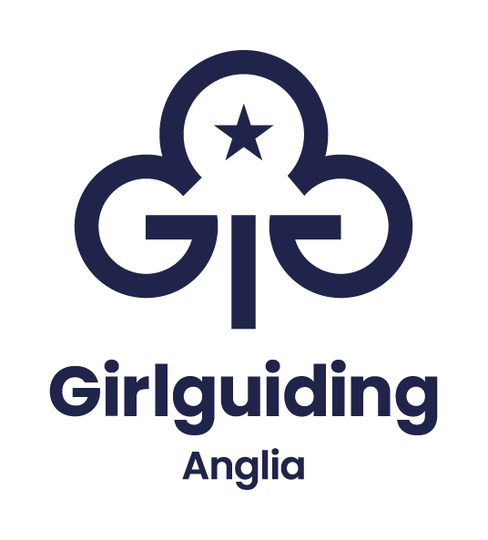
Insert a current passport -sized photograph here

Application form for Girlguiding Anglia international selection.
Please complete this form clearly in black ink as it will be photocopied.
Personal Details
What name do you prefer to be known by:
First name (including middle names)
Surname:
Address:

Postcode:
Telephone number (incl. area code):
Mobile:
Email: please print clearly
Email of parent/carer please print clearly
Date of birth:
Age in years as at 1st July 2025
Nationality:
Date passport expires:
School:
Your Girlguiding career
Present position in Girlguiding UK:
Ie: Young leader with Brownies, Guide, Leader
Name of unit:
Membership number (essential):
District:
Division:
County:
How long have you been in Girlguiding (years) as a:
Rainbow
Brownie
Guide
Ranger
Young leader
Leader
Other (please specify)
Your Girlguiding experience
Camp experience (under canvas)
Nights as a Brownie
As a Guide
As a Ranger
As a young leader
With school
With my family
As a leader
Do you hold a campers badge, permit (which ones)
Experience within Girlguiding
Outdoor activities

Service projects

Qualifications or skills

Other experience
If you are a student, what are you studying and where?
Please list any qualifications you have:

International experiences
Which countries have you visited in the past 5 years and what kind of trip? (jamboree, holiday, exchange)
In guiding?
With family, friends, alone?
With school?
Do you speak any additional languages? To what ability/level?
Other
Interests/hobbies outside Girlguiding:

Do you hold any positions of responsibility outside Girlguiding?

Use this space to tell us about yourself, your family and your local community

Use this space to tell us why you would like to experience an international experience with Girlguiding

Please use extra paper where necessary.
Other qualifications, skills or experience you would like to mention:
Do you have any religious, health, mobility or sensory needs which we should be aware?
In order that appropriate opportunities are arranged and to ensure everyone’s wellbeing during an event it is important that any issues you are aware of are listed here
I would like to be considered for a Girlguiding Anglia international opportunity. I confirm that the information on this application is accurate and a true record of my experience.
Signed: ………………………………………………………………………………………………………………..
Date: ……………………………………..
Read and signed by:
International advisor: ………………………………………………………………………………….
Date: ………………………………………

Email address ………………………………………………………………………………………………….
For applicants under 18: As a parent or guardian I confirm that the above information is correct and I am happy for this application to be considered for further opportunities which may involve travelling overseas.
Parent/carer ………………………………………………………………………………………………………..
Date: ……………………………………………

